

**PrepPal**



**PrepPal:** **Intelligent Web-Based Platform for Enhanced Emergency Preparedness Assistance with Child-Friendly Features**

**By**

Haya Falah Mohammed 442770011

Alhanouf Majdul Saud 442770004

Bushra Abdullah Ibrahim 439770191

Aysha Abdullah Salem 442830252

Dina Mohammed Shamlan 441770025

Engineering Department of Computer and Information

College of Engineering in Wadi Addawasir

Prince Sattam Bin Abdulaziz University

Wadi Addawasir, Riyadh Region

Saudi Arabia

2024-1445

**PrepPal:** **Intelligent Web-Based Platform for Enhanced Emergency Preparedness Assistance with Child-Friendly Features**

**By**

Haya Falah Mohammed 442770011

Alhanouf Majdul Saud 442770004

Bushra Abdullah Ibrahim 439770191

Aysha Abdullah Salem 442830252

Dina Mohammed Shamlan 441770025

A Final year Project Report Submitted in partial fulfillment of the

Requirements for the award of a bachelor’s degree in computer science

Supervised by: Dr.Jana Shafi

Engineering Department of Computer and Information

College of Engineering in Wadi Addawasir

Prince Sattam Bin Abdulaziz University

Wadi Addawasir, Riyadh Region

Saudi Arabia

2024-1445

|  |
| --- |
|  |

**CERTIFICATE OF COMPLETION**

This is to certify that the project report titled **“PrepPal: Intelligent Web-Based Platform for Enhanced Emergency Preparedness Assistance with Child-Friendly Features“**was prepared by: Haya Falah Mohammed (442770011) - Alhanouf Majdul Saud( 442770004) - Bushra Abdullah Ibrahim(439770191) -Aysha Abdullah Salem(442830252) - Dina Mohammed Shamlan (441770025) towards Final year partial fulfillment of the requirements for the award of bachelor’s degree in Computer science.The results of the investigation enclosed in this report have been verified and found satisfactory.

**We accept this report as conforming to the required standards**

**1. Mrs. Leila Ben Njima 2. Dr.Jana Shafi**

(Chairman) (Supervisor)

**3.** __________________ **4**. ________________

(Examiner) (Examiner)

**DECLARATION**

We hereby declare that this project report is based on our original work except for citations

and quotations which have been duly acknowledged. We also declare that it has not been

previously or concurrently submitted for any other degree at Prince Sattam Bin Abdul-Aziz

University.

|  |  |
| --- | --- |
| Haya Falah Mohammed | ID: 442770011 |
| Signature: | Date: |
| Alhanouf Majdul Saud | ID: 442770004 |
| Signature: | Date: |
| Bushra Abdullah Ibrahim | ID: 439770191 |
| Signature: | Date: |
| Aysha Abdullah Salem | ID: 442830252 |
| Signature: | Date: |
| Dina Mohammed Shamlan | ID: 441770025 |
| Signature: | Date: |

**APPROVAL FOR SUBMISSION**

I certify that this project report entitled **“PrepPal: Intelligent Web-Based Platform for Enhanced Emergency Preparedness Assistance with Child-Friendly Features “**was prepared by: Haya Falah Mohammed (442770011) - Alhanouf Majdul Saud( 442770004) - Bushra Abdullah Ibrahim (439770191) - Aysha Abdullah Salem(442830252) - Dina Mohammed Shamlan (441770025) has met the requires standard for submission in partial fulfillment of the requirement for the degree of Bachelor of Computer Science at Prince Sattam Bin Abdul- Aziz University.

**Signature**:

**Supervisor**: **Dr.Jana Shafi**

**Date**:

**ACKNOWLEDGEMENT**

We would like to express our sincere gratitude to Allah, the Almighty, for the countless blessings we have received and for giving us the determination to successfully complete this graduation project.

We would also like to extend our sincere appreciation to **Dr. Jana Shafi** for her invaluable guidance and supervision throughout our project. Her expertise and support have been instrumental in our personal and academic growth. We are truly grateful for her mentorship, inspiration, and constructive feedback, which have greatly contributed to our achievements.Furthermore, we would like to acknowledge our fellow classmates for their unwavering support and the healthy competition that motivated us to strive for excellence in our studies. Their presence in our academic journey has been crucial to our accomplishments.

Lastly, we owe a special debt of gratitude to our parents. Their love, support, and guidance have been the driving force behind our achievements. We are genuinely appreciative of their constant encouragement, which has propelled us forward on our path to success.

**Student’s Name** **Student’s ID**

Haya Falah Mohammed 442770011

Alhanouf Majdul Saud 442770004

Bushra Abdullah Ibrahim 439770191

Aysha Abdullah Salem 442830252

Dina Mohammed Shamlan 441770025

**ABSTRACT**

Every year, millions of people worldwide face the recurring threat of natural and human-made disasters. Effective emergency preparedness is crucial, yet existing methods often lack interactivity and fail to cater to diverse individual needs, especially those of children. To address these challenges, we propose an innovative intelligent web platform that combines Laravel, a robust PHP framework, with artificial intelligence (AI) technologies.

The platform aims to enhance emergency preparedness by providing comprehensive features and incorporating child-friendly elements for ages (4-10). Through gamification techniques, users can learn about different types of emergencies, practice emergency procedures, and receive personalized recommendations based on their unique requirements. The platform creates an engaging and immersive environment with interactive visuals, animations, and age-appropriate content specifically designed to capture children’s attention and facilitate their understanding of emergency situations.

Furthermore, the platform prioritizes inclusivity by incorporating accessibility features such as screen readers and closed captions, accommodating users with diverse needs and abilities. Importantly, our innovative web platform, combining Laravel and AI technologies, aims to enhance emergency preparedness by addressing diverse types of crises, including biological, chemical, radiological, natural disasters, and technological emergencies. It will operate under parental or guardian supervision, ensuring a safe and educational experience for children.

The expected findings of this research project include demonstrating improved usability and functionality of the platform, increasing emergency preparedness knowledge and skills among users, particularly children, and enhancing the overall effectiveness of the platform through AI-powered personalized recommendations. These findings will contribute valuable insights to the knowledge base on effective emergency preparedness strategies for researchers, practitioners, and policymakers in the field.

**ABSTRACT(Arabic)**

يواجه الملايين من الأشخاص حول العالم تهديدات الكوارث الطبيعية والناجمة عن البشر سنويًا، مما يؤكد على الحاجة الملحة لاتخاذ تدابير فعّالة للتأهب للطوارئ. ومع ذلك، تفتقر الطرق الحالية غالبًا إلى التفاعلية وتفشل في تلبية متطلبات الأفراد المتنوعة، وخاصة الأطفال. لمعالجة هذه التحديات، نقترح منصة ويب ذكية مبتكرة تجمع بين Laravel، الإطار القوي للـ PHP، وتقنيات الذكاء الاصطناعي. (AI).

تهدف المنصة إلى تعزيز الاستعداد للطوارئ من خلال توفير ميزات شاملة ودمج عناصر صديقة للأطفال من عمر(4-10). من خلال تقنيات الألعاب، يمكن للمستخدمين التعرف على أنواع مختلفة من الطوارئ، وممارسة إجراءات الطوارئ، والحصول على توصيات مخصصة استنادًا إلى احتياجاتهم الفردية. تخلق المنصة بيئة جذابة ومشوقة مع رسوم متحركة ومحتوى مناسب للأعمار مصمم خصيصًا لجذب انتباه الأطفال وتسهيل فهمهم للحالات الطارئة.

علاوةً على ذلك، تولي المنصة أهميةً للشمولية من خلال دمج ميزات الوصول مثل قارئي الشاشة والترجمة المغلقة، مما يستوعب مستخدمين ذوي احتياجات وقدرات متنوعة. وبشكلٍ مهم، تهدف منصتنا الويب المبتكرة، التي تجمع بين Laravel وتقنيات الذكاء الاصطناعي، إلى تعزيز الاستعداد للطوارئ من خلال التعامل مع أنواع متنوعة من الأزمات، بما في ذلك الطوارئ البيولوجية والكيميائية والإشعاعية والكوارث الطبيعية والطوارئ التكنولوجية. ونؤكد بشكل خاص أن هذا الموقع سيكون تحت إشراف الآباء والأمهات أو الأوصياء أو المعلمين لضمان تجربة آمنة وتعليمية للأطفال.

من المتوقع أن تظهر نتائج هذا المشروع البحثي تحسينًا في استخدام المنصة ووظائفها، وزيادة معرفة ومهارات الاستعداد للطوارئ بين المستخدمين، وخاصة الأطفال، وتعزيز الفعالية العامة للمنصة من خلال التوصيات المخصصة بواسطة الذكاء الاصطناعي. ستساهم هذه النتائج في قاعدة المعرفة حول استراتيجيات الاستعداد للطوارئ الفعّالة، وتقديم رؤى قيمة للباحثين والممارسين وصانعي القرار في مجال الطوارئ.

# Table of Contents

Table of Contents viii

List of figures x

List of tables xi

CHAPTER ONE: OVERVIEW 1

1.1 Introduction 1

1.2 Motivation 2

1.3 Aims and Objectives 2

1.3.1 Objectives 3

1.3.2 Aims 3

1.4 System Specification 3

1.4.1 Software Requirements 3

1.5 Web Modules 4

1.5.1 Backend Server 4

1.5.2 Frontend side 5

1.6. Survey 7

1.6.1. Data Collection 14

CHAPTER TWO: LITERATURE REVIEW 15

2.1 Introduction 15

2.2. Background 15

2.2.1 Early Developments 15

2.2.2 Recent Developments 16

2.2.3 Challenges of Intelligent Web-Based Emergency Preparedness Platform 17

2.2.4 Research Gaps 18

2.3 Existing Platforms 18

2.3.1 Information Platforms 19

2.3.2 Education Platforms 19

2.3.3 Recommandation Platforms 20

2.4 summary 21

CHAPTER THREE: SYSTEM ANALYSIS AND DESIGN 22

3.1 Introduction 22

3.2 System Development Life Cycle (SDLC) 22

3.2.1 Types of SDLC 23

3.2.2 Choosing The Right Type Of SDLC 23

3.2.3 SDLC Steps 23

3.3 Agile SDLC Development 24

3.3.1 Agile Principles 25

3.3.2 Agile Practices 25

3.3.3 Agile Benefits 25

3.3.4 Agile Challenges 26

3.4 System Requirements 26

3.4.1 System Description 26

3.4.3 System Constraints 27

3.4.4 Functional Requirements 27

3.4.5 System Requirements 27

3.4.6 User Requirements 28

3.4.7 Non-functional Requirements 28

3.5 UML (Unified Modeling Language) 28

3.5.1 Use case diagram 28

3.5.2 Sequence diagram 32

3.5.3 User Registraion Sequence diagram 32

3.5.4 Login Sequence diagram 33

3.5.5 User Interaction Sequence Diagram 34

3.5.6 Activity Diagram 35

3.5.7 User Interaction Activity Diagram 35

3.5.8 Admin Activity Diagram 37

3.5.9 Entity Relationship Diagram 38

3.5.10 UML Class Diagram 39

References 49

# List of figures

Figure 1-1. High-Level System Data Flow 6

Figure 1-2. Questionnaire Result 1 7

Figure 1-2. Questionnaire Result 1 7

Figure 1-3. Questionnaire Result 2 7

Figure 1-3. Questionnaire Result 2 8

Figure 1-4. Questionnaire Result 3 9

Figure 1-5. Questionnaire Result 4 9

Figure 1-5. Questionnaire Result 4 10

Figure 1-6. Questionnaire Result 5 11

Figure 1-7. Questionnaire Result 6 12

Figure 1-8. Questionnaire Result 7 13

Figure 3-1. Sdlc 22

# List of tables

Table3- 1. View Emergency Information Usecase 29

Table3- 1. View Emergency Information Usecase 29

Table 3-2. Register/Sign In Usecase 29

Table 3-3. Manage Profile Usecase 29

Table 3-4. Receive Alerts Usecase 30

Table 3-5. Administrate Platform Usecase 30

Table 3-6. Generate Reports Usecase 30

Table 3-7. Data Analysis Usecase 30

Table 3-8. Interactive Learning Modules Usecase 31

# CHAPTER ONE: OVERVIEW

1.1 Introduction

Every year, millions of people around the world face the threat of natural disasters, such as earthquakes, floods, and hurricanes, or human-made disasters, such as wars, terrorist attacks, and industrial accidents. These emergencies can have devastating consequences for the lives, health, and property of individuals and communities [1] . Therefore, it is essential to be prepared for such events and to know how to respond effectively and safely.

However, emergency preparedness is not a simple or straightforward task. It requires access to reliable and relevant information, resources, and training. Moreover, it requires the involvement and participation of all members of society, including children, who are often overlooked or excluded from emergency preparedness activities [2]. Children are not only more vulnerable to the effects of disasters, but they also have different needs and preferences than adults. Therefore, they need emergency preparedness assistance that is tailored to their age, level of understanding, and interests.

This project proposes to develop an intelligent web-based platform that provides enhanced emergency preparedness assistance with child-friendly features. The platform will be built using the Laravel framework, which is a powerful and flexible PHP framework known for its robustness and scalability [3]. Additionally, the platform will incorporate artificial intelligence (AI) technologies to provide personalized and adaptive emergency preparedness recommendations based on user profiles, demographics, and historical data. The use of AI will enable the platform to continuously learn and improve its recommendations over time, ensuring that users receive the most relevant and effective guidance.

Furthermore, the platform will offer a comprehensive and user-friendly set of features and tools that will enable users to learn about different types of emergencies and how to cope with them. It will utilize interactive visuals, animations, and age-appropriate content to educate and engage children in emergency preparedness. Gamification elements, such as quizzes, challenges, and rewards, will be implemented to motivate and incentivize children to actively participate in emergency preparedness activities.

Accessibility and inclusivity are paramount considerations in the platform's development. Features such as screen readers, closed captions, and alternative text descriptions for images will be implemented to ensure that users with disabilities or impairments can fully access and benefit from the platform.

The main goal and purpose of this project proposal is to demonstrate the feasibility, benefits, and innovation of the proposed platform. By leveraging Laravel's robust environment and integrating AI technologies, the platform aims to address the problem of emergency preparedness and improve the well-being and safety of individuals, especially children, in the face of emergencies.

## 1.2 Motivation

Emergency preparedness is a skill that can make a difference between life and death. Every day, millions of people around the world are exposed to the risk of natural disasters or terrorist attacks, which can have devastating consequences for their lives, health, and property. However, many people are not adequately prepared for such events, and do not know how to respond effectively and safely. This is especially true for children, who are more vulnerable and less informed than adults. Therefore, there is a need for a web-based platform that can assist individuals, including children, in learning and practicing emergency preparedness in a convenient, accessible, and engaging way.

The main motivation behind this project is to bridge the gap in accessible and personalized emergency preparedness assistance. Traditional methods of disseminating information about emergency procedures often lack interactivity and fail to cater to the unique requirements of different individuals, especially children. By leveraging the power of technology, artificial intelligence, and user-centric design, this project endeavors to provide an innovative solution that empowers individuals of all ages to be better prepared for emergencies.

1.3 Aims and Objectives

The primary aims of this project are as follows:

1. To develop an intelligent web-based platform that enhances emergency preparedness assistance with child-friendly features.
2. To provide a comprehensive set of features and tools that help users learn about different types of emergencies and how to respond to them effectively.
3. To create a simulated environment where users can practice emergency procedures using realistic sounds and notifications.
4. To offer personalized emergency preparedness recommendations based on users' profiles, demographics, and historical data.
5. To enable user interaction with the platform using artificial intelligence (AI) capabilities that analyze their interactions and adapt the content and features to their needs and preferences.
6. To enhance engagement by incorporating gamification elements such as quizzes, challenges, and rewards.

### 1.3.1 Objectives

1. The specific objectives of this project are as follows:
2. To conduct a literature review on the existing research and best practices on emergency preparedness and web-based platforms.
3. To design and develop a prototype of the intelligent web-based platform using Laravel as the development environment and integrating various AI services and APIs.
4. To evaluate the usability, functionality, and effectiveness of the platform using user testing and feedback methods.
5. To analyze the results and findings of the evaluation and provide recommendations for future improvements and enhancements.

### 1.3.2 Aims

The project aims to:

1. Establish the need for an intelligent web-based platform that caters to the specific requirements of individuals, especially children, in preparing for emergencies.
2. Explore the existing challenges and gaps in traditional methods of emergency preparedness assistance.
3. Provide a theoretical foundation by reviewing relevant literature on emergency preparedness, web-based platforms, and the integration of artificial intelligence.
4. Present the research question and problem statement that guide this project.
5. Outline the research methodology and approach for achieving the project objectives.
6. Give an overview of the structure and organization of the dissertation.

1.4 System Specification

### 1.4.1 Software Requirements

Backend Requirements:

1. Laravel: Laravel is a popular and powerful PHP framework that can be used to develop web applications. Laravel provides many features and tools that make web development easier and faster, such as dependency injection, database abstraction, queues, testing, and more. Laravel also supports various frontend technologies, such as Vue, React, Bootstrap, and Tailwind.
2. MySQL: MySQL is a widely used open-source relational database management system that can store and manage data for web applications. MySQL can handle large and complex data sets and offers high performance, security, and scalability.
3. Redis: Redis is an in-memory data structure store that can be used as a database, cache, or message broker. Redis can store and manipulate various data types, such as strings, lists, sets, hashes, and more. Redis can also support transactions, pub/sub, and Lua scripting.
4. Laravel Sail: Laravel Sail is a lightweight command-line interface for interacting with Laravel's default Docker configuration. Sail provides a great starting point for building a Laravel application using PHP, MySQL, and Redis without requiring prior Docker experience.

Frontend Requirements:

1. Vue: Vue is a progressive framework for building user interfaces for web applications. Vue is easy to use and integrate with other libraries or existing projects. Vue also offers a rich set of features and tools, such as reactivity, components, routing, state management, and more.
2. Bootstrap: Bootstrap is a popular and responsive CSS framework that can help design and customize the look and feel of web applications. Bootstrap provides a collection of reusable and customizable components, such as buttons, forms, tables, cards, and more. Bootstrap also offers a grid system, utilities, and icons.
3. Axios: Axios is a promise-based HTTP client that can be used to make requests to backend servers or APIs. Axios can handle various HTTP methods, such as GET, POST, PUT, and DELETE. Axios can also support interceptors, timeouts, cancellation, and more.

1.5 Web Modules

The web module would include the following components:

1.5.1 Backend Server

1. Models: Models will represent the data structures and relationships of our platform, such as users, emergencies, sounds, notifications, etc. Models will also interact with the MySQL database and perform CRUD (Create, Read, Update, Delete) operations.
2. Views: Views will generate the HTML responses for the frontend side, such as the welcome page, the dashboard page, the profile page, etc. Views will also use Blade, Laravel's templating engine, to display dynamic data and content.
3. Controllers: Controllers will handle the HTTP requests and responses from the frontend side and perform the business logic and data processing of our platform. Controllers will also integrate with various artificial intelligence services and APIs and use Laravel's built-in features and tools, such as validation, authentication, authorization, etc.
4. Routes: Routes will define the URLs and endpoints of our platform and map them to the corresponding controllers and methods. Routes will also use middleware, filters, and groups to control the access and behavior of the requests and responses.
5. Migrations: Migrations will define the schema and structure of the MySQLdatabase for our platform and create or modify the necessary tables and columns. Migrations will also enable version control and easy deployment of the database changes.
6. Seeders: Seeders will populate the MySQL database with initial data, such as sample users, emergencies, sounds, etc., for testing and demonstration purposes.
7. Middleware: Middleware will intercept and modify the HTTP requests and responses at various stages of the request lifecycle. Middleware can be used for tasks such as authentication, authorization, validation, logging, etc.
8. Event Listeners: Event Listeners will listen for specific events or triggers in our platform, such as a new emergency being reported or a user updating their profile. Event Listeners can perform additional actions or tasks based on these events, such as sending notifications, updating statistics, etc.
9. Jobs: Jobs will represent background tasks or processes that can be queued and executed asynchronously. Jobs can be used for tasks such as sending emails, processing images, generating reports, etc. Jobs can also leverage Laravel's queue system and Redis for improved performance and scalability.

### 1.5.2 Frontend side

1. Components: Components will represent the reusable and customizable elements of the user interface, such as headers, footers, menus, buttons, forms, tables, cards, etc. Components will also use props, slots, and events to communicate and interact with each other.
2. Views: Views will represent the pages or screens of the user interface, such as the welcome page, the dashboard page, the profile page, etc. Views will also use Vue Router, a routing library for Vue, to navigate and switch between different views.
3. Store: Store will represent the centralized and global state of the application, such as the user data, the emergency data, the sounds, the notifications, etc. Store will also use Vuex, a state management library for Vue, to manage and mutate the state, and to perform actions and getters.
4. Services: Services will represent the functions and methods that communicate with the backend server or APIs, and perform HTTP requests and responses. Services will also use Axios, an HTTP client for Vue, to handle various HTTP methods, such as GET, POST, PUT, and DELETE.

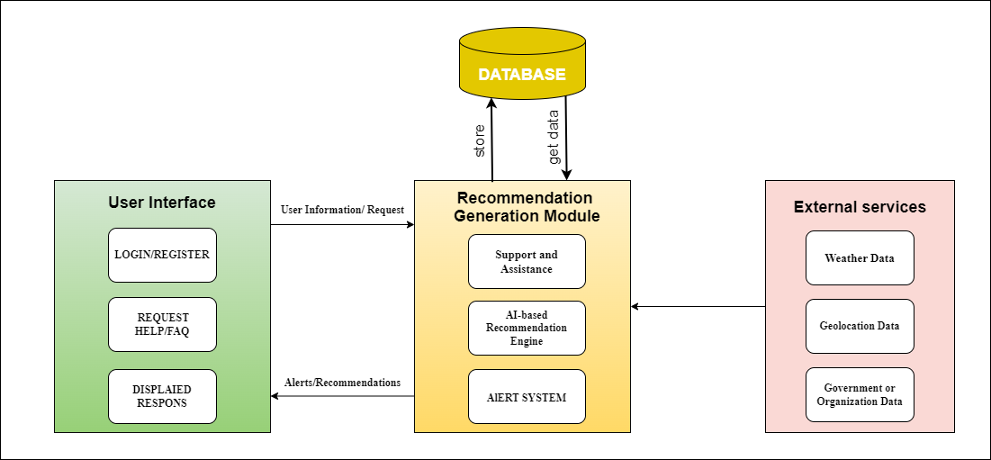The system architecture for our web platform can follow a client-server architecture.Here is a high-level system data flow diagram:

*Figure 1-1. High-Level System Data Flow*

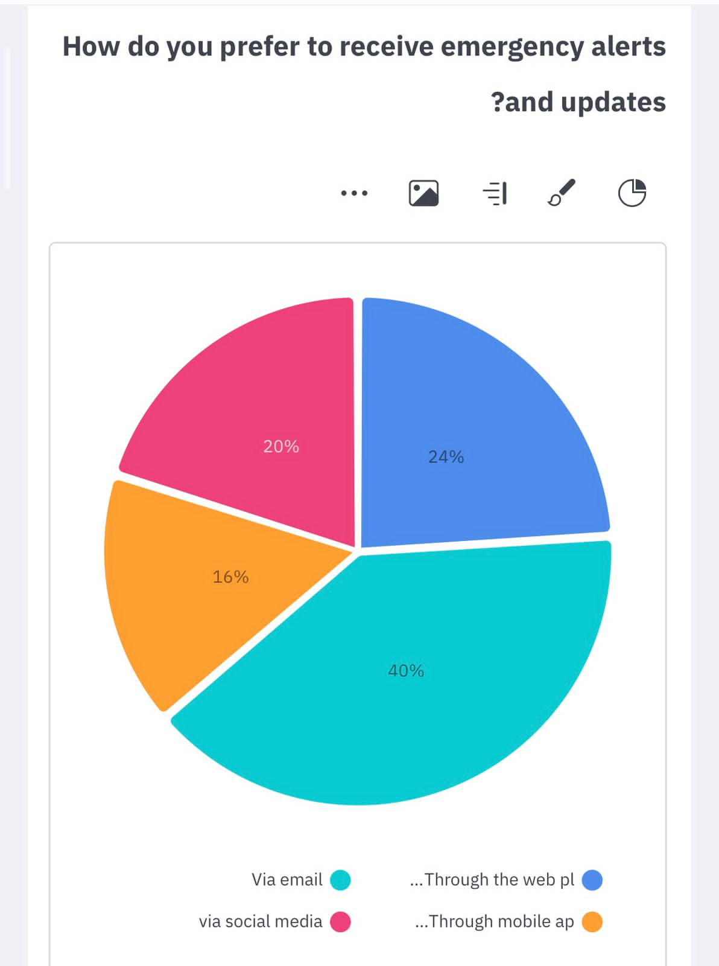1.6. Survey

##### *Figure 1-2. Questionnaire result 1*

*Figure 1-2. Questionnaire result 1*

##### *Figure 1-3. Questionnaire result 2*

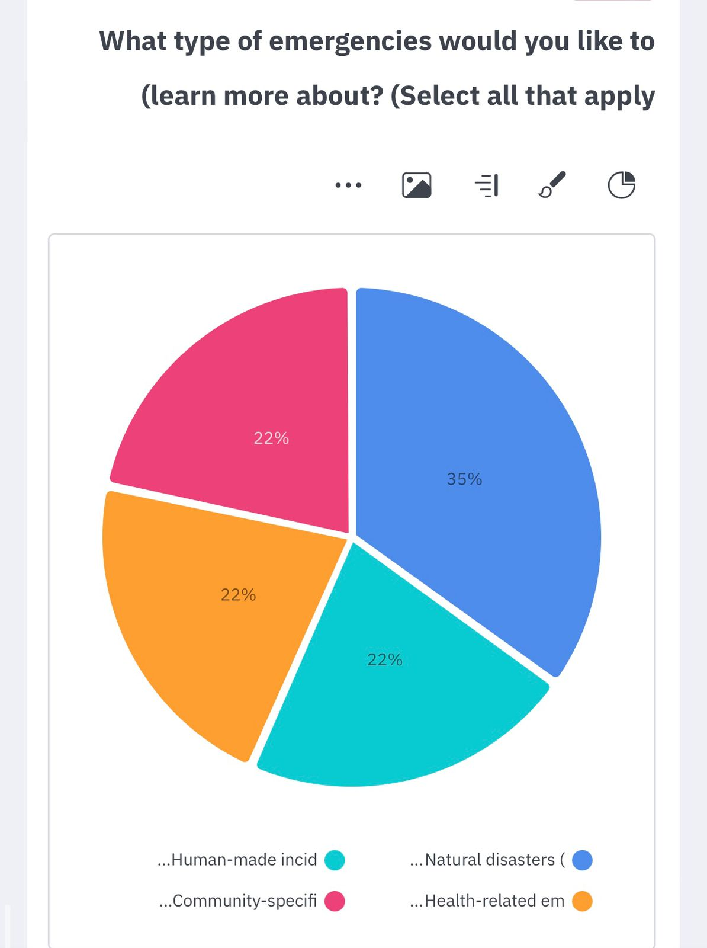

##### *Figure 1-3. Questionnaire result 2*

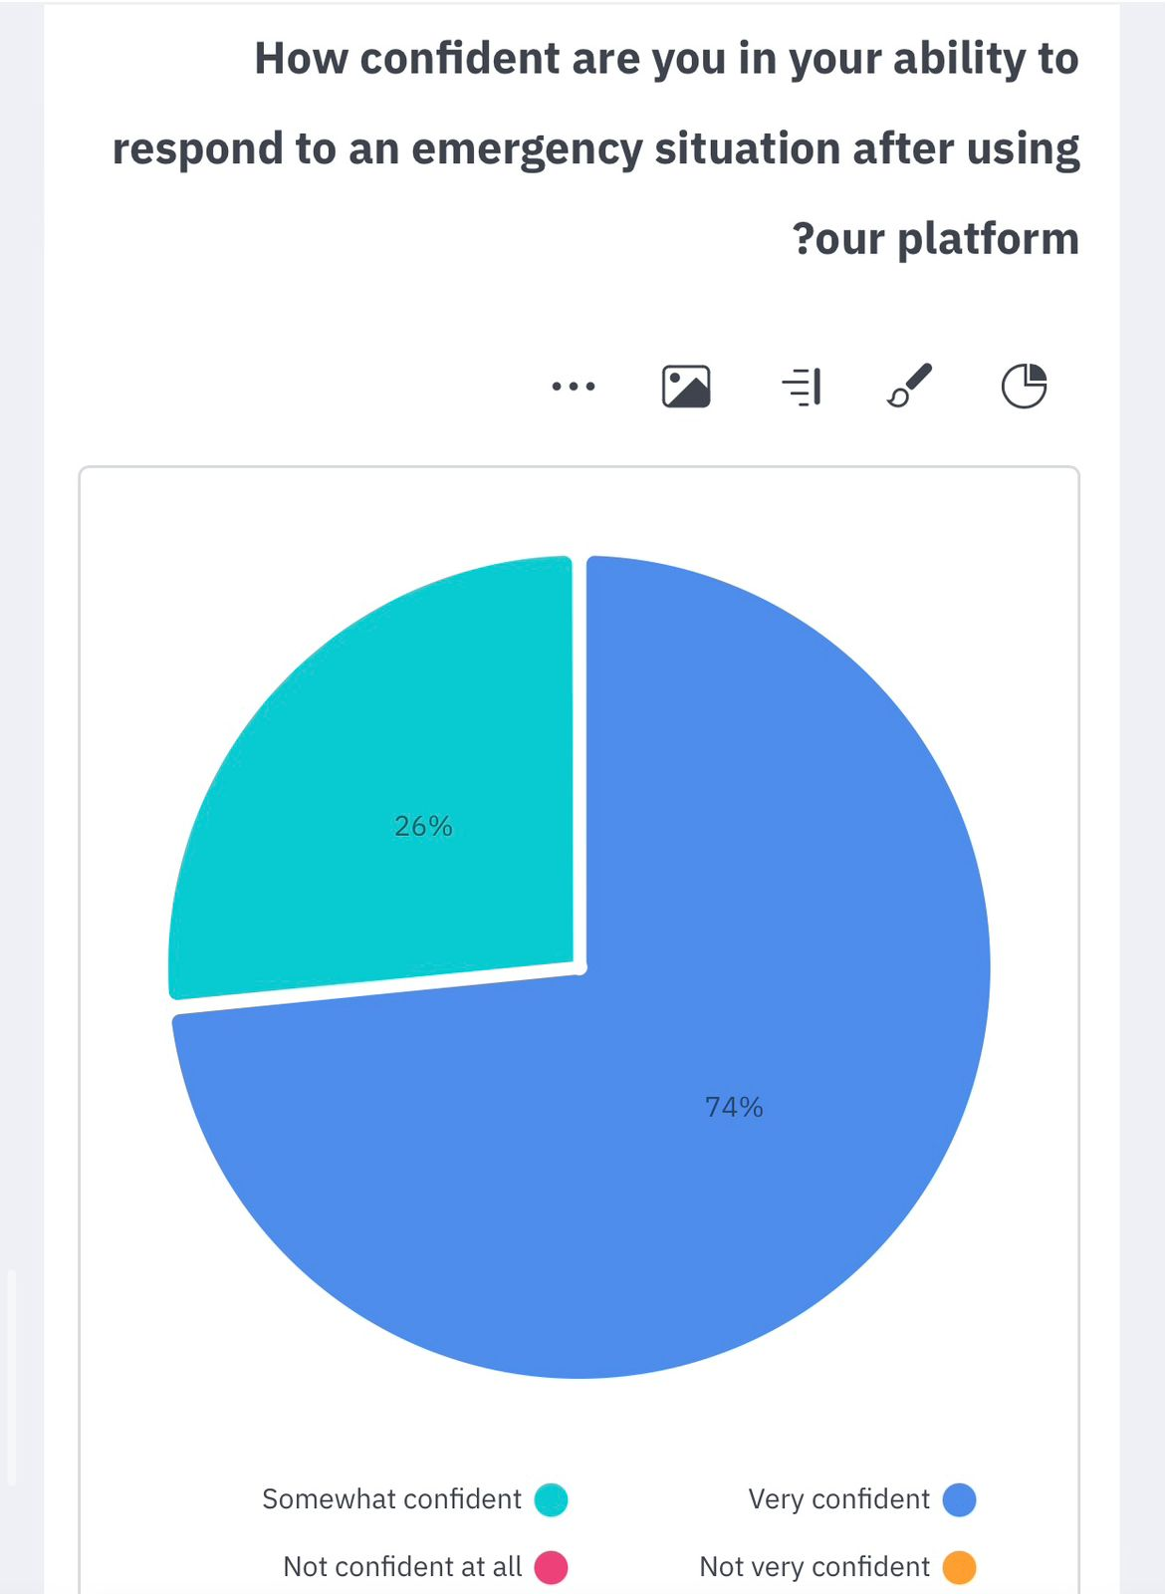

##### *Figure 1-4. Questionnaire result 3*

##### *Figure 1-5. Questionnaire result 4*

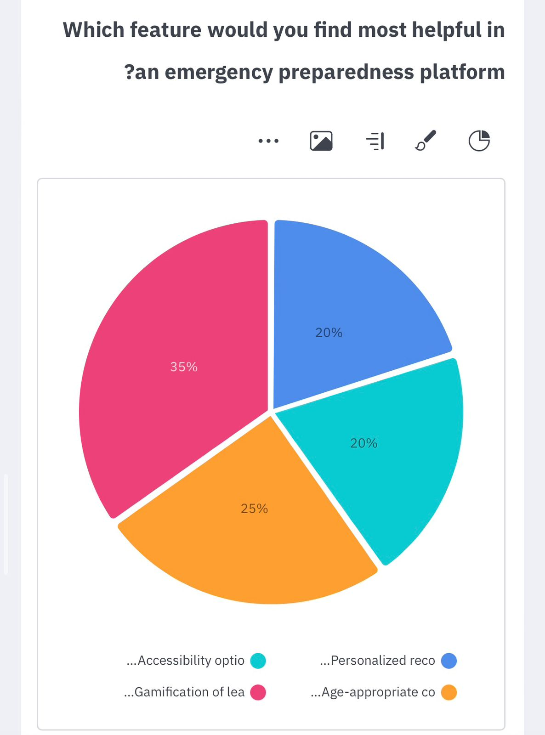

##### *Figure 1-5. Questionnaire result 4*

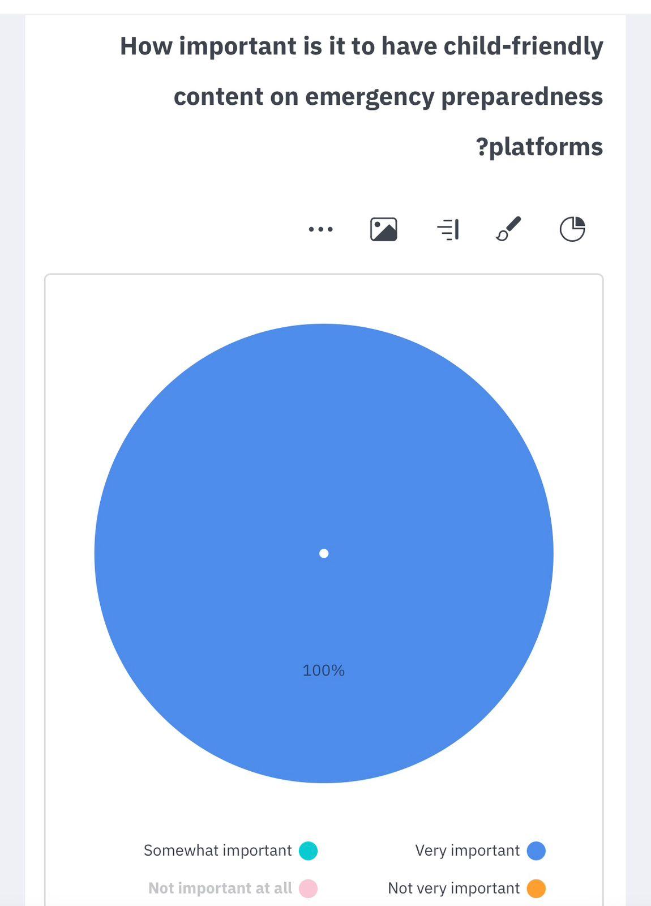

##### *Figure 1-6. Questionnaire result 5*

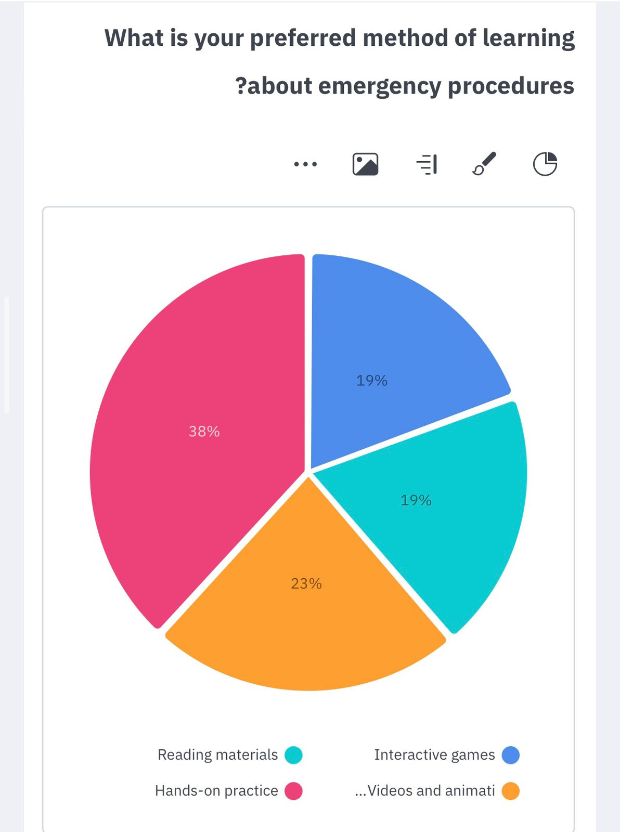

##### *Figure 1-7. Questionnaire result 6*

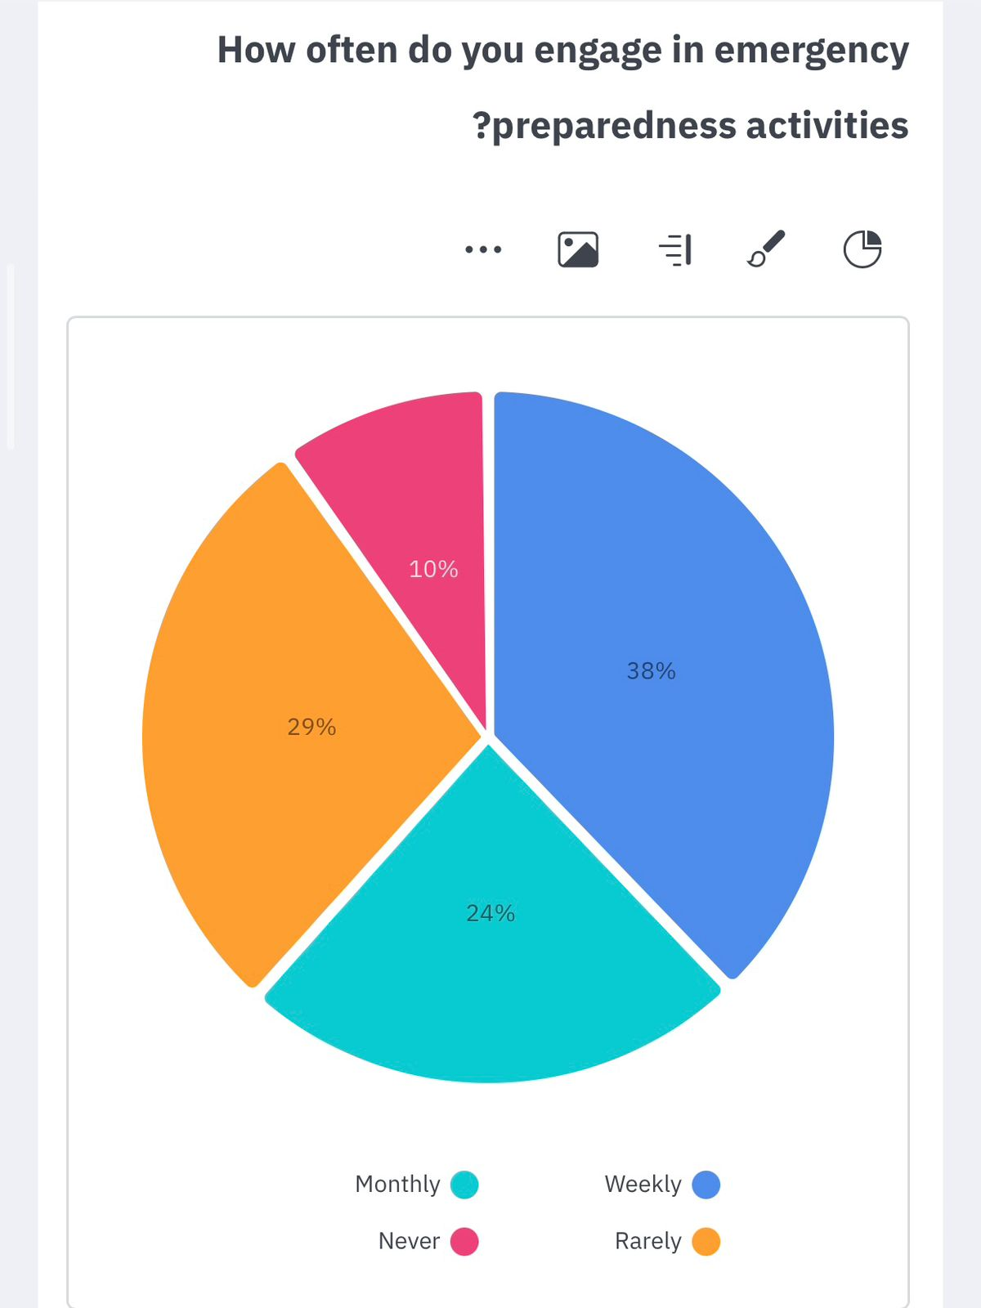

##### *Figure 1-8. Questionnaire result 7*

1.6.1. Data Collection

The PrepPal project’s data collection was carried out through an online questionnaire that sought to assess the platform’s effectiveness in bolstering emergency preparedness, particularly for young users. A total of 108 participants contributed to the survey, providing essential insights into their involvement with emergency preparedness activities, preferred learning methods, and the significance of child-friendly content on such platforms.

Firstly, the participants’ frequency of engaging in emergency preparedness activities was categorized as weekly (38%), monthly (24%), rarely (29%), and never (10%).

Secondly, the preferred learning methods for emergency procedures were interactive games (19%), reading materials (19%), videos and animations (23%), and hands-on practice (38%).

Thirdly, the importance of child-friendly content on emergency preparedness platforms was unanimously deemed very important by all respondents.

Fourthly, the most beneficial features of an emergency preparedness platform were identified as personalized recommendations (20%), accessibility options (20%), age-appropriate content and visuals (25%), and gamification of learning content (35%).

Fifthly, the confidence levels of respondents in their ability to respond to an emergency after using the platform were reported as very confident (74%) and somewhat confident (26%).

Sixthly, the types of emergencies that participants were interested in learning more about included natural disasters (35%), human-made incidents (22%), health-related emergencies (22%), and community-specific emergencies (22%).

Lastly, the preferred methods for receiving emergency alerts and updates were through the web platform (24%), via email (40%), through mobile app notifications (16%), and via social media (20%).

The insights gathered from this questionnaire are pivotal in refining the PrepPal platform to more effectively meet the needs of its users and to solidify its role as a valuable educational tool for emergency preparedness.

# CHAPTER TWO: LITERATURE REVIEW



## **2.1 Introduction**

Emergencies, crises, and disasters (ECDs) are complex, uncertain, and evolving phenomena that pose significant challenges to the safety and well-being of people and communities around the world [4]. Enhancing emergency preparedness and response (EP&R) is a vital and urgent task for reducing the risks and impacts of ECDs [5]. One of the promising ways to achieve this goal is to develop intelligent web-based platforms that can provide enhanced EP&R assistance with user-friendly features. These platforms can leverage artificial intelligence (AI) and data science to offer personalized and interactive support for users before, during, and after ECDs [6]. For example, these platforms can use gamification techniques, interactive visuals, and adaptive content to engage users and enhance their understanding of ECD situations and procedures [7]. Additionally, these platforms can use AI technologies such as natural language processing, computer vision, and machine learning to provide personalized recommendations based on individual needs and capabilities.

This chapter aims to provide a comprehensive and critical review of the literature on the development of intelligent web-based platforms for enhanced EP&R assistance. The literature review covers the following aspects: the early and recent developments in the field, the challenges and research gaps, the existing platforms and their evaluation, and the future directions and opportunities for further research.

## **2.2. Background**

This section provides an overview of the background of the research area, including the early and recent developments in the field of intelligent web-based platforms for enhanced EP&R assistance.

### 2.2.1 Early Developments

The field of Emergency Preparedness and Response (EP&R) has a long history of research and practice, dating back to the 1950s [1]. Initially, the focus was on traditional methods of delivering EP&R information and education, such as printed materials, training sessions, public service announcements, and drills. However, these methods had limitations in terms of interactivity, scalability, personalization, and addressing the specific needs of different user groups [8].

Printed materials, including brochures, posters, and manuals, were often inaccessible, outdated, or irrelevant to the users. Training sessions, such as workshops, courses, and exercises, were often costly, time-consuming, or inconvenient for the users. Public service announcements through radio, television, and newspapers were frequently ignored, forgotten, or misunderstood by the users. Drills, such as fire, earthquake, and evacuation drills, were often unrealistic, disruptive, or stressful for the users [8].

Recognizing the importance of tailoring EP&R efforts to different demographics, researchers and practitioners began exploring innovative approaches. Participatory methods, such as community-based planning, risk mapping, and scenario analysis, were introduced to involve users in the EP&R process and increase their awareness and ownership [9]. Child-friendly methods, such as puppet shows, storybooks, and games, were also adopted to educate and empower children and their caregivers about EP&R in a fun and engaging way [10]. These early innovations marked a shift from a top-down, one-size-fits-all approach to a bottom-up, user-centered approach in EP&R [8].

### 2.2.2 Recent Developments

The field of emergency preparedness and response (EP&R) has witnessed significant advancements in recent years, spurred by the integration of technology, particularly web-based platforms, aimed at enhancing EP&R [11]. These web-based platforms offer numerous advantages compared to traditional methods of delivering EP&R information and education. They provide accessibility, flexibility, cost-effectiveness, and user engagement. Furthermore, web-based platforms can reach a large number of users across different locations and devices, providing timely and updated information and guidance [11]. Users can choose their preferred mode and pace of learning, and receive feedback and reinforcement to stay motivated. Additionally, these platforms reduce the costs and resources required for EP&R, such as printing, distribution, and personnel [12].

The emergence of artificial intelligence (AI) and data science has further revolutionized web-based platforms, enabling the development of intelligent systems that offer personalized and interactive support throughout the emergency and crisis duration (ECD) [7]. These platforms leverage various AI technologies, including natural language processing, computer vision, machine learning, and recommender systems. Natural language processing enables the platforms to understand and generate natural language texts and speech, such as chatbots, FAQs, and summaries [7]. Computer vision allows recognition and processing of images and videos, such as maps, satellite images, and live feeds .Machine learning enables the platforms to learn from data and enhance their performance in prediction, classification, and clustering. Recommender systems provide personalized recommendations based on individual needs and capabilities, such as learning materials, actions, and resources [7].

Furthermore, these platforms employ gamification techniques, interactive visuals, and age-appropriate content to engage users and improve their understanding of ECD situations and procedures. Gamification techniques, such as points, badges, levels, leaderboards, and rewards, make the learning process more enjoyable and challenging .Interactive visuals, including animations, simulations, and games, create immersive and realistic learning experiences. Age-appropriate content, such as stories, characters, and scenarios, ensures the learning process is relevant and relatable. These intelligent platforms have demonstrated promising results in enhancing users' knowledge, skills, and behavior regarding EP&R, as well as their satisfaction and motivation [4].

### 2.2.3 Challenges of Intelligent Web-Based Emergency Preparedness Platform

The development of intelligent web-based platforms for enhanced emergency preparedness and response (EP&R) assistance comes with several challenges that require careful consideration and resolution. These challenges can be categorized into three main areas: content, accessibility, and evaluation.

Content challenges revolve around the creation and maintenance of comprehensive and accurate content that caters to the specific needs of different user groups and emergency scenarios. It is crucial to develop content that effectively conveys EP&R information and procedures in a manner that engages users and ensures their understanding. However, this task is complex and requires a deep understanding of the EP&R domain, user characteristics, and learning objectives. Additionally, the content needs to be regularly updated and validated to reflect changes in EP&R situations and procedures across different regions. Furthermore, the content should be adaptable and personalized to meet the diverse needs and preferences of users, such as language, culture, age, and ability [13], [4].

Accessibility challenges pertain to ensuring that the web-based platform is accessible and inclusive for users with diverse needs and abilities. Accessibility means that the platform can be utilized by individuals regardless of their physical, cognitive, or sensory limitations. Inclusivity, on the other hand, aims to accommodate the unique characteristics and promote the active participation and empowerment of all users. Achieving these goals requires careful design and evaluation of the platform's interface, functionality, and content. However, there may be trade-offs between accessibility and other design considerations, such as usability, efficiency, and security [14],[15].

Evaluation challenges involve assessing the impact and effectiveness of the intelligent web-based platform on users' knowledge, skills, and behaviors related to EP&R. Evaluating the platform's impact is crucial for demonstrating its value and identifying areas for improvement. However, this task is challenging and necessitates a rigorous and comprehensive methodology capable of measuring both quantitative and qualitative outcomes. It also requires a large and representative sample of users, long-term and longitudinal observations, and reliable and valid measurement instruments to obtain accurate results [15].

Addressing these challenges is essential for the successful development and deployment of intelligent web-based platforms for enhanced EP&R assistance. By overcoming these obstacles, we can ensure that such platforms effectively support emergency management efforts, improve preparedness and response capabilities, and ultimately contribute to saving lives and minimizing the impact of disasters.

### 2.2.4 Research Gaps

While significant progress has been made in the development of intelligent web-based platforms for enhanced Emergency Preparedness and Response (EP&R) assistance, there are still research gaps that need to be addressed [4]. These research gaps can be categorized into two main areas: theoretical and practical.

Theoretical research gaps revolve around the absence of a comprehensive and systematic framework that can guide the design, development, and evaluation of intelligent web-based platforms for enhanced EP&R assistance. A robust framework should consider various aspects, including the specific domain of Emergency, Crisis, and Disaster (ECD), user characteristics, platform features, AI techniques, and evaluation methods. It should also account for the trade-offs and challenges associated with each aspect, such as content quality, accessibility, and impact measurement. Additionally, the framework should be adaptable and scalable to different ECD scenarios and user groups [4],[ 15].

Practical research gaps pertain to the lack of empirical evidence and real-world applications that can demonstrate the effectiveness and potential of intelligent web-based platforms for enhanced EP&R assistance. Many existing studies rely on simulations, experiments, or surveys, which may not accurately reflect actual ECD situations and user behaviors. Furthermore, most existing platforms are either prototypes, demos, or pilots, limiting their widespread adoption and deployment in real-world settings. Thus, there is a need for more field studies, case studies, and longitudinal studies to evaluate the impact and effectiveness of intelligent web-based platforms for enhanced EP&R assistance in real-world ECD scenarios and user groups [12], [13].

## **2.3 Existing Platforms**

This section examines the current intelligent web-based platforms that offer enhanced assistance for emergency preparedness and response (EP&R). The strengths and limitations of these platforms will be evaluated. The platforms can be categorized into three types based on their primary functions: information, education, and recommendation.

2.3.1 Information Platforms

Information platforms aim to provide users with timely and relevant data regarding emergency and crisis situations, including alerts, updates, statistics, and maps. These platforms utilize natural language processing and computer vision techniques to process and present data from diverse sources such as sensors, satellites, social media, and news. Here are a few examples of information platforms:

1. DisasterAWARE: Developed by the Pacific Disaster Center, DisasterAWARE offers situational awareness and decision support for emergency and crisis events. The platform integrates data from multiple sources and employs AI to analyze and visualize the information on a web-based interface. Additionally, it provides alerts, reports, and forecasts for emergency and crisis events[16].
2. AI for Disaster Response (AIDR): Created by the Qatar Computing Research Institute, AIDR leverages AI to collect and classify social media data related to emergency and crisis events. The platform utilizes machine learning and natural language processing to filter and categorize the data based on topics, sentiments, and locations. AIDR also provides a dashboard and an API for accessing and visualizing the collected data[17].
3. Saudi Arabia Emergency Management System (SAEMS): Developed by the Saudi Arabia Ministry of Interior, SAEMS is a unified and integrated platform for managing emergency and crisis events in the country. The platform employs a web-based portal and a mobile app to offer information and services to the public and authorities. AI is utilized to monitor and analyze the emergency and crisis situation and provide recommendations and actions[18].

Information platforms offer the advantage of providing accurate, up-to-date, and comprehensive information regarding emergency and crisis events, enabling users to stay informed and prepared. However, these platforms may have limitations in terms of personalized and interactive support for users, as well as challenges related to data quality, security, and privacy.

2.3.2 Education Platforms

Education platforms are intelligent web-based platforms that provide users with interactive and engaging learning experiences about ECDs, such as games, simulations, and quizzes. These platforms use gamification techniques and adaptive content to motivate users and enhance their knowledge and skills related to EP&R. Some examples of education platforms are:

1. Ready Wrigley: A platform developed by the CDC that provides educational materials and activities for children aged 2-8 years old to prepare for ECDs. The platform uses a cartoon dog character named Wrigley to teach children about ECDs through storybooks, games, coloring pages, and songs [19].
2. Disaster Hero: A platform developed by the American College of Emergency Physicians that provides an online game for children aged 7-12 years old to learn about ECDs. The platform uses a superhero theme to challenge children to complete missions and mini-games related to ECDs, such as fire, flood, earthquake, and pandemic [20].
3. Prepare with Pedro: A platform developed by the American Red Cross that provides a mobile app for children aged 4-7 years old to learn about ECDs. The platform uses a penguin character named Pedro to guide children through interactive stories and games related to ECDs, such as tornado, hurricane, wildfire, and home fire [21].

The strengths of education platforms are that they can provide users with fun and immersive learning experiences about ECDs, which can help them improve their knowledge and skills related to EP&R. The limitations of education platforms are that they may not be able to provide personalized and contextualized support for users, and they may face challenges of content validity, user retention, and learning assessment.

However, it's important to consider the limitations of education platforms:

1. Lack of personalization: Education platforms may struggle to provide personalized and contextualized support to individual users, as they often cater to a broad audience with varying needs and backgrounds.
2. Content validity: Ensuring the accuracy and relevance of the educational content within these platforms can be challenging, as the field of EP&R is constantly evolving.
3. User retention: Sustaining user engagement and retention over an extended period can be a challenge, as individuals may lose interest or face competing priorities.
4. Learning assessment: Assessing the effectiveness and impact of education platforms in terms of knowledge retention and practical application of EP&R skills can be complex.

2.3.3 Recommandation Platforms

Recommendation platforms are intelligent web-based platforms that provide users with personalized and contextualized guidance and advice for EP&R, such as actions, resources, and contacts. These platforms use recommender systems and machine learning to analyze user data, such as location, preferences, capabilities, and behavior, and provide customized suggestions that suit their needs and situations. Some examples of recommendation platforms are:

1. Ready: A platform developed by the US Department of Homeland Security that provides users with personalized recommendations for EP&R based on their location, household, and hazards. The platform uses a web-based interface and a mobile app to help users create an emergency plan, build an emergency kit, and stay informed about ECDs[22].
2. Disaster Preparedness and Response Assistant (DPRA): A platform developed by the University of Southern California that provides users with personalized recommendations for EP&R based on their profile, preferences, and behavior. The platform uses a conversational agent and a mobile app to interact with users and provide them with information, feedback, and reminders about ECDs [23].

The strengths of recommendation platforms are that they can provide users with tailored and relevant guidance and advice for EP&R, which can help them to make better decisions and take appropriate actions. The limitations of recommendation platforms are that they may not be able to provide comprehensive and reliable support for users, and that they may face challenges of data availability, accuracy, and privacy.

## **2.4 summary**

This chapter reviewed the current intelligent web-based platforms for emergency preparedness and response (EP&R) assistance. They are classified into three types: information, education, and recommendation platforms. Information platforms provide data and insights on emergency and crisis events, but they may lack the ability to engage and support users in a personalized and interactive way. Education platforms offer fun and immersive learning experiences on EP&R, but they may face challenges of personalization, content validity, user retention, and learning assessment. Recommendation platforms give personalized and contextualized guidance and advice for EP&R, but they may encounter issues of data quality, privacy, and ethics. Future research should address these limitations and gaps to improve the effectiveness and usability of these platforms for EP&R. These platforms have the potential to enhance EP&R efforts by providing information, education, and recommendation to individuals and communities, and ultimately save lives and reduce the impact of disasters.

# CHAPTER THREE: SYSTEM ANALYSIS AND DESIGN

## **3.1 Introduction**

This chapter delves into the systematic analysis and design of an intelligent web platform, meticulously crafted to enhance emergency preparedness. The platform, developed with Laravel and artificial intelligence technologies, stands as a testament to the power of modern software engineering in creating robust, user-centric systems.

We will explore the analytical framework that guides the platform's development, detailing the functional and non-functional requirements that shape its capabilities. The chapter will also dissect the architectural design, providing insight into the platform's infrastructure and the interdependencies of its components.

Embracing a user-centric design philosophy, the platform is tailored to be intuitive, engaging, and informative, with particular emphasis on making the content accessible and appealing to children. Interactive elements and gamification are woven into the fabric of the platform, ensuring an educational experience that is both immersive and effective.

## **3.2 System Development Life Cycle (SDLC)**

The System Development Life Cycle (SDLC) is an essential paradigm in software engineering, providing a systematic approach to the creation and maintenance of information systems. It ensures that products are developed with high quality and meet user requirements. The SDLC framework supports the entire process from initial planning to the final deployment and beyond.

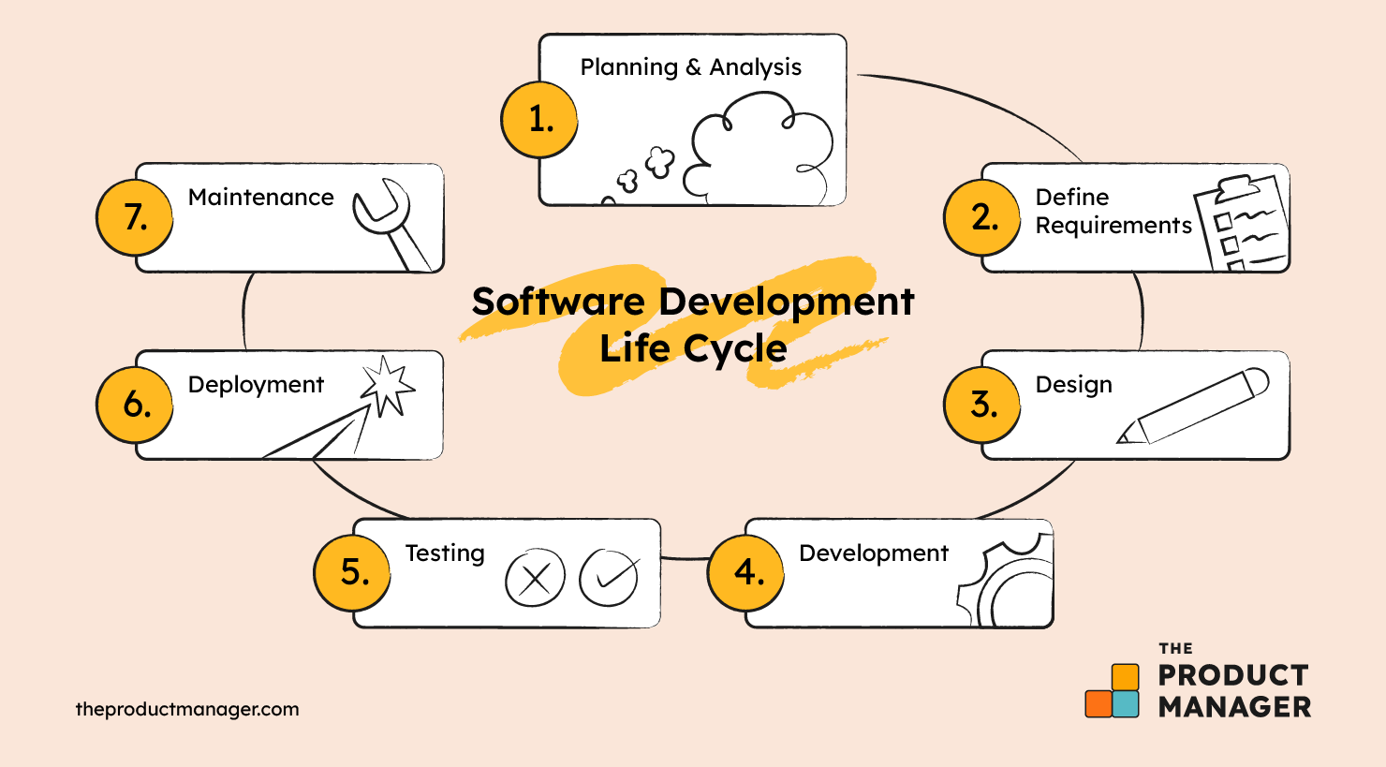

*Figure 3-1. SDLC*

### 3.2.1 Types of SDLC

Several SDLC methodologies are employed in the industry, each with its unique characteristics and best-use scenarios:

1. Waterfall Mode A linear and sequential approach where progress flows in one direction downwards like a waterfall through the phases of conception, initiation, analysis, design, construction, testing, deployment, and maintenance.
2. Agile Model: A highly iterative and incremental process, Agile allows for more flexibility and is responsive to changing requirements throughout the development process.
3. Spiral Model:This model combines the iterative nature of the Agile model with the controlled aspects of the Waterfall model, adding a focus on risk analysis.
4. V-Model (Validation and Verification model): An extension of the Waterfall model that emphasizes the validation and verification of each stage within the development process[24].

### 3.2.2 [Choosing](http://3.2.2.Choosing) The Right Type Of SDLC

limited to the project’s scale, intricacy, intended outcomes, and existing limitations. It is imperative that the chosen SDLC model harmonizes with the specific demands of the project, aligns with the anticipations of stakeholders, and complements the dynamics of the development team.

For a platform that integrates Laravel and artificial intelligence technologies to enhance emergency preparedness, an Agile SDLC model may be the most suitable. Agile methodologies, such as Scrum or Kanban, are characterized by their iterative nature and flexibility, allowing for continuous integration and adaptation to changing requirements.

### 3.2.3 SDLC Steps

SDLC consists of the following steps:

1. Planning & Analysis: This initial phase involves gathering business requirements from stakeholders and defining the scope of the software project. It sets the stage for all subsequent activities in the development process.
2. Requirements Gathering: Once the planning is complete, the next step is to translate the gathered information into detailed requirements for the development team. This phase ensures that the software will meet the needs of the users and stakeholders.
3. Design: In this phase, architects and developers create the software's architecture and design documents, which serve as blueprints for the implementation phase. The design must address all the defined requirements.
4. Implementation: The actual coding of the software takes place during this phase. Developers build the system based on the design documents, adhering to coding standards and best practices.
5. Testing: After development, the software undergoes rigorous testing to identify and fix any defects. This phase verifies that the software functions correctly and meets the specified requirements.
6. Deployment: Once testing is complete and the software is deemed stable, it is deployed to a production environment where it becomes available for use.
7. Maintenance: The final phase involves ongoing support for the software, including bug fixes, performance enhancements, and any necessary updates to keep the system running smoothly and efficiently[26].

## 3.3 Agile SDLC Development

The Agile Software Development Life Cycle (SDLC) is a flexible, iterative approach that emphasizes collaboration, customer feedback, and rapid delivery of functional software. It contrasts with traditional, linear development models by accommodating change and focusing on the continuous improvement of the product throughout its development cycle[27].

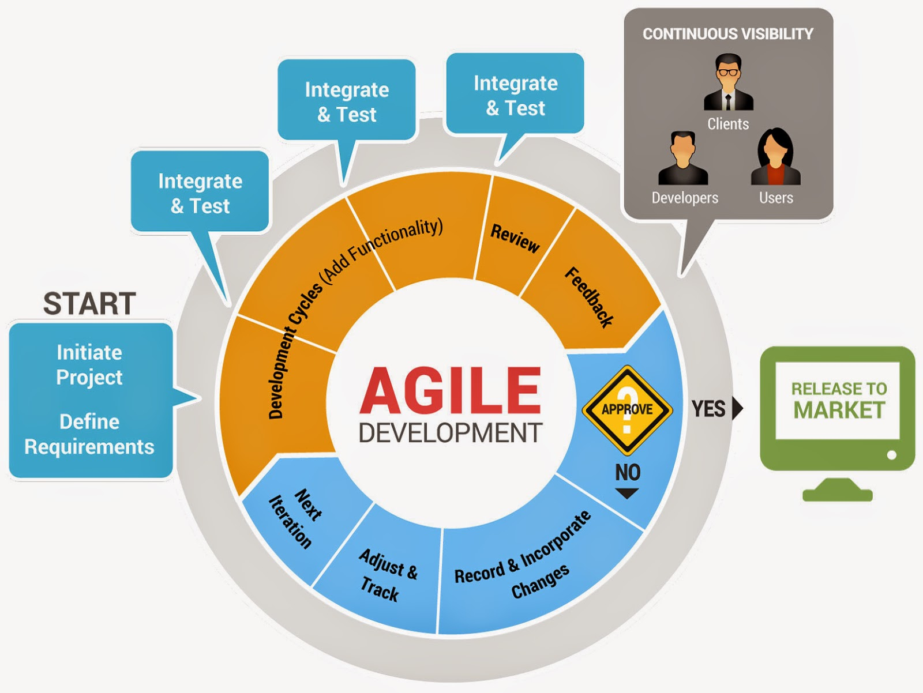

Figure 3-2. Agile Model

### 3.3.1 Agile Principles

Agile development is underpinned by several key principles:

1. Individuals and Interactions Over Processes and Tools: Agile prioritizes effective collaboration and communication over rigid adherence to tools and processes.
2. Working Software Over Comprehensive Documentation: Delivering functional software is more valuable than providing extensive documentation.
3. Customer Collaboration Over Contract Negotiation: Agile encourages ongoing engagement with the customer to ensure the product meets their needs and expectations.
4. Responding to Change Over Following a Plan: Agile is adaptable, allowing teams to respond to changes in requirements, even late in the development process[28].

### 3.3.2 Agile Practices

Agile development typically involves the following practices:

1. Sprints: Development is divided into short, time-boxed periods called sprints, where a set of features is developed and delivered.
2. Daily Stand-ups: Regular meetings help the team to stay aligned and address any impediments quickly.
3. User Stories: Requirements are captured as user stories, which are short, simple descriptions of a feature from the perspective of the end-user.
4. Continuous Integration and Deployment: Agile promotes frequent integration of code changes and quick deployment to production.
5. Retrospectives: After each sprint, the team reflects on what went well and what could be improved for the next iteration.

### 3.3.3 Agile Benefits

The benefits of Agile SDLC include:

1. Increased Flexibility: Agile allows for changes to be made after the initial planning. New or changing requirements can be accommodated throughout the development process.
2. Enhanced Customer Satisfaction: By involving the customer in the development process and focusing on delivering working software quickly, Agile helps ensure that the final product meets the customer's needs.
3. Improved Product Quality: Regular testing and reviews during the development cycles mean that quality is built into the product from early in the process.
4. Reduced Risk: Agile's iterative nature allows for early discovery of issues, reducing the risk of project failure.

### 3.3.4 Agile Challenges

While Agile offers many advantages, it also presents challenges such as:

1. Scope Creep: Without careful management, the flexibility of Agile can lead to continuous changes and feature additions, potentially impacting timelines and budgets.
2. Team Dependency: Agile requires a highly collaborative team that is self-organizing and cross-functional. Teams that lack these characteristics may struggle with Agile methodologies.

Overall, Agile SDLC is a powerful approach to software development that supports the dynamic needs of modern software projects. It is particularly suitable for projects where requirements are expected to change or are not fully understood at the outset. The iterative nature of Agile allows for continuous improvement and adaptation, ensuring that the software evolves to meet the needs of its users effectively.

## 3.4 System Requirements

### 3.4.1 System Description

The system in question is an advanced web-based platform engineered to elevate the standards of emergency preparedness through a blend of interactive learning experiences and personalized content powered by artificial intelligence. Developed utilizing the robust Laravel framework, the platform is designed to serve as an educational tool that not only informs but also engages users in a meaningful way. It is particularly tailored to cater to the unique learning styles of children, incorporating elements that make learning about emergency preparedness intuitive and captivating. The intelligent aspect of the platform is manifested in its ability to adapt content and learning paths to individual user interactions, ensuring a highly personalized experience.

**3.4.2** [**System**](http://3.4.2.System)**Environments**

The platform is architected to be universally accessible, operating seamlessly across a multitude of web environments. It is optimized for performance across various devices, including desktops, tablets, and smartphones, ensuring a consistent user experience regardless of the access point. The system is hosted on a scalable cloud infrastructure, which provides the necessary elasticity to handle fluctuating user loads and data demands. This environment is meticulously configured to maintain high availability, ensuring that users can rely on the platform at all times, especially during critical learning moments or when accessing vital information during emergencies.

### 3.4.3 [System](http://3.4.3.System) Constraints

The system's architecture, while robust and flexible, operates within certain constraints that must be acknowledged. These constraints are inherent to the web-based nature of the platform and the advanced technologies it employs. Internet connectivity is a fundamental requirement, as the platform's resources are accessed online, which could limit usage in areas with poor connectivity. Browser compatibility is another consideration; the platform must be optimized for a variety of browsers to ensure a broad user reach. Additionally, the AI components of the system necessitate ongoing data input and refinement to maintain the relevance and accuracy of the personalized content. These constraints are critical factors in the design and deployment of the platform and must be carefully managed to minimize their impact on user experience.

### 3.4.4 Functional Requirements

The functional requirements of the platform are pivotal in dictating its operational efficacy and user engagement. These requirements encompass:

1. User Authentication and Profile Management: The system must provide a secure and efficient means for users to create and access their accounts, with the ability to manage personal profiles and customize their learning experience.
2. Dynamic Content Generation: Leveraging AI, the platform should dynamically generate content that adapts to the user's progress and preferences, ensuring a personalized learning journey.
3. Real-Time Notifications and Alerts: It is imperative that the platform delivers immediate notifications and alerts, keeping users abreast of urgent updates and emergency information.
4. Gamification Elements: To foster an engaging learning environment, the platform should incorporate gamification elements such as points, badges, and interactive challenges, particularly designed to captivate and motivate young learners.

### 3.4.5 System Requirements

The system requirements are technical specifications necessary for the platform to function optimally:

1. Robust Server Infrastructure: A resilient server setup capable of handling variable user traffic and ensuring consistent performance is essential.
2. Database Systems: Secure and scalable database solutions are required to store and manage the vast array of user data and educational content.
3. Integration with AI Services: The platform must seamlessly integrate with advanced AI services to facilitate content personalization and deliver an adaptive learning experience.

### 3.4.6 User Requirements

User requirements focus on the expectations and needs of the end-users, which include:

1. Intuitive User Interface: The platform should boast an intuitive interface that allows users of all ages to navigate with ease and without confusion.
2. Accessibility Features: It is crucial to incorporate features that make the platform accessible to users with disabilities, ensuring inclusivity.
3. Multilingual Support: To cater to a global audience, the platform must support multiple languages, breaking down language barriers in emergency preparedness education.

### 3.4.7 Non-functional Requirements

Non-functional requirements are criteria that define the operation of the system, rather than specific behaviors:

1. Scalability: The platform must be designed to scale, accommodating an increasing number of users without degradation in performance.
2. Security: Robust security protocols must be in place to protect sensitive user data and ensure privacy.
3. Compliance: The platform should comply with relevant educational standards and regulations, maintaining high-quality content and ethical standards.

## 3.5 UML (Unified Modeling Language)

Unified Modeling Language (UML) is a comprehensive modeling language that architects, software engineers, and systems analysts use to visualize, specify, construct, and document the artifacts of software systems. UML provides a way to design blueprints for a system, including its structure and design, before the actual development begins.

### [**3.5.1**](tel:3.5.1) **Use case diagram**

A use case diagram is a graphical depiction of the interactions between the users of a system and the system itself, representing the specifications of a system’s behavior. It illustrates the functional requirements of a system from the user’s perspective, helping to capture the intended behavior of the system. The primary components of a use case diagram include:

1. Actors: These are the entities that interact with the system. Actors can be individuals, groups, or external systems that perform roles in the system.
2. Use Cases: These are the actions or processes that the actors perform with the system. Each use case represents a set of scenarios that convey how the system should interact with the actor to achieve a specific goal.
3. System Boundary: This defines the scope of the system and encapsulates the use cases, indicating what is included within the system.

The diagram includes the following actors:

1. User: Any person who interacts with the platform, whether they are logged in or not. This includes visitors browsing the platform without logging in and registered users who have signed up and are logged in.
2. Administrator: A user with elevated privileges who manages the platform’s content and user accounts.
3. System: The backend processes and automated responses of the platform, which facilitate the functionality presented to the User and Administrator.

The diagram includes the following use Cases :

##### Table3- 1. View Emergency Information UseCase

##### Table3- 1. View Emergency Information UseCase

|  |  |
| --- | --- |
| **UseCase Name** | View Emergency Information |
| **Actor** | User (Visitor or Registered) |
| **Description** | Users can view current emergency information and advice. |
| **Precondition** | User accesses the platform. |
| **Postcondition** | User is informed about emergencies. |
| **Basic Flow** | 1. User selects emergency info.  2. System displays information. |
| **Alternative Flow** | If the user is not registered, prompt to register for detailed information. |

|  |  |
| --- | --- |
| **UseCase Name** | *Register/Sign* |
| **Actor** | User (Visitor) |
| **Description** | Visitors can create an account or sign in to access personalized features. |
| **Precondition** | User is on the login page. |
| **Postcondition** | User has an account and is logged in. |
| **Basic Flow** | 1. User enters credentials.  2. System verifies and grants access. |
| **Alternative Flow** | If credentials are incorrect, offer password recovery. |

##### Table 3-2. Register/Sign In UseCase

##### Table 3-3. Manage Profile UseCase

|  |  |
| --- | --- |
| **UseCase Name** | Manage Profile |
| **Actor** | User(Registered) |
| **Description** | Users can manage their profiles and set preferences. |
| **Precondition** | User is logged in. |
| **Postcondition** | User's profile is updated. |
| **Basic Flow** | 1. User edits profile.  2. System saves changes. |
| **Alternative Flow** | If the user wants to delete the account, provide a separate flow for account deletion. |

##### Table 3-4. Receive Alerts UseCase

|  |  |
| --- | --- |
| **UseCase Name** | Receive Alerts |
| **Actor** | Registered User |
| **Description** | Users receive real-time alerts about emergencies. |
| **Precondition** | User has notifications enabled. |
| **Postcondition** | User is notified of emergencies. |
| **Basic Flow** | 1. Emergency occurs.  2. System sends alert. |
| **Alternative Flow** | If the user has alerts disabled, provide an option to enable them. |
| **Verification** | Verify Alert Subscription |

##### Table 3-5. Administrate Platform useCase

|  |  |
| --- | --- |
| **UseCase Name** | Administrate Platform |
| **Actor** | Admin |
| **Description** | Admins manage platform content and user accounts. |
| **Precondition** | Admin is logged in with privileges. |
| **Postcondition** | Platform content is managed. |
| **Basic Flow** | 1. Admin edits content.  2. System updates changes. |
| **Alternative Flow** | If admin privileges are insufficient, request elevation. |

##### Table 3-6. Generate Reports useCase

|  |  |
| --- | --- |
| **UseCase Name** | Generate Reports |
| **Actor** | Administrator, System (automated) |
| **Description** | Generate reports on user engagement and emergency data. |
| **Precondition** | Data is available for reporting period. |
| **Postcondition** | Reports are generated and accessible to authorized users. |
| **Basic Flow** | 1. Admin selects report type and timeframe.  2. System compiles and presents data in a user-friendly format. |
| **Alternative Flow** | If criteria are too broad, prompt admin to refine selection for a more focused report. |

##### Table 3-7. Data Analysis useCase

|  |  |
| --- | --- |
| **UseCase Name** | Data Analysis |
| **Actor** | System |
| **Description** | Analyze user data to personalize content, improve platform functionality, and identify potential emergencies. |
| **Precondition** | User data is collected through various interactions. |
| **Postcondition** | Insights are generated for personalization, platform improvement, and early warning systems (optional). |
| **Basic Flow** | 1. System collects and anonymizes user data.  2. System analyzes data to identify trends and patterns.  3. Insights are used to personalize content and suggest improvements. |
| **Alternative Flow** | If data is insufficient for meaningful analysis, continue collecting data until a statistically significant sample size is reached. |

##### Table 3-8. Interactive Learning Modules useCase

|  |  |
| --- | --- |
| **UseCase Name** | Interactive Learning Modules |
| **Actor** | Registered User |
| **Description** | Engage with educational content through interactive modules. |
| **Precondition** | User is logged in and selects a module. |
| **Postcondition** | User completes the module and gains knowledge. |
| **Basic Flow** | 1. User selects a module.  2. System presents content. |
| **Alternative Flow** | If the user selects an advanced module, guide them to prerequisites. |

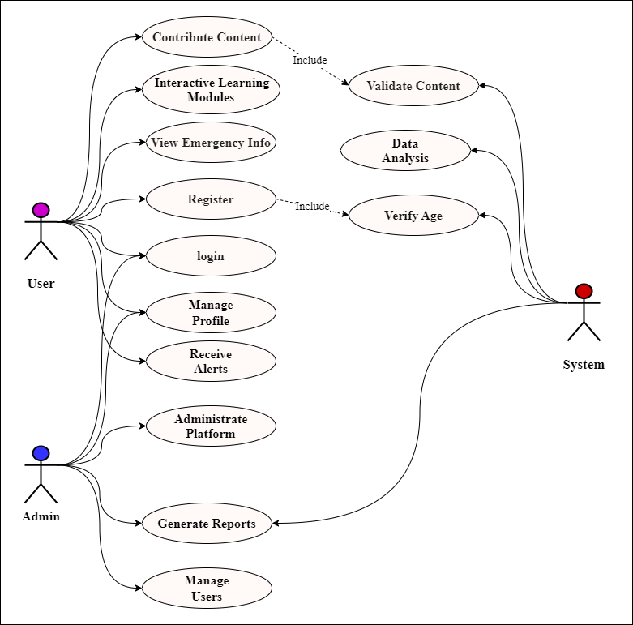

Figure 3-3. Use case diagram of the proposed System

### [**3.5.2**](tel:3.5.1)**Sequence diagram**

The sequence diagram is a type of interaction diagram that shows how processes operate with one another and in what order. It is a constructive tool to model the dynamic aspects of the system. A sequence diagram is primarily used to visualize the sequence of messages passed between different objects or components in a system.

In the context of our emergency preparedness platform, the sequence diagram will illustrate the interactions involved in the “Contribute Content” use case. This includes the flow of messages from the moment a registered user decides to submit content, through the system’s processing of that content, to the potential need for content revision based on validation by a reviewer.

### [**3.5.3**](tel:3.5.1) **User Registraion Sequence diagram**

The User Registration Sequence Diagram is a dynamic representation of the interaction between a user and the system during the registration process. It illustrates the sequence of messages exchanged between the objects involved, providing a clear visualization of the flow of events from the initiation of the registration to the successful creation of a user account.

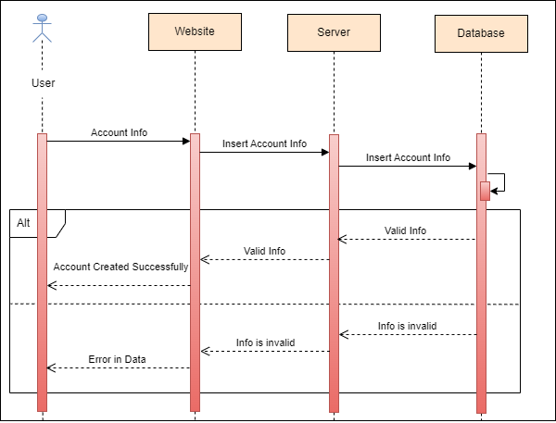

Figure 3-4. User Registraion Sequence diagram

### [**3.5.4**](tel:3.5.1) **Login Sequence diagram**

The Login Sequence Diagram illustrates the systematic process by which both users and administrators gain access to the system. This diagram is pivotal in understanding the authentication mechanism that ensures secure and authorized entry into the system. It delineates the interactions between the system and the actors users and administrators highlighting the steps taken from initiating a login request to successfully establishing a session.

For users and Admin, the sequence begins with the submission of their credentials, which are then verified against the stored data. Upon successful validation, users are granted access to their respective accounts, tailored to their privileges.

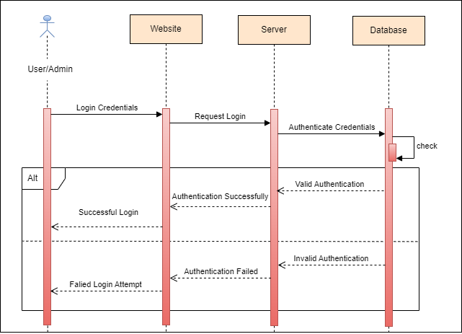

Figure 3-5. Login Sequence diagram

### [**3.5.5**](tel:3.5.1) **User Interaction Sequence Diagram**

The User Interaction Sequence Diagram demonstrates the essential interactions between users and the emergency preparedness platform. This diagram showcases the platform's dedication to delivering an intuitive and seamless user experience. It outlines the systematic journey a user follows, starting from accessing personalized educational content to staying informed about emergencies. The diagram presents the core interactions that ensure users can effectively utilize the platform's features.

Figure 3-6. User Interaction Sequence diagram

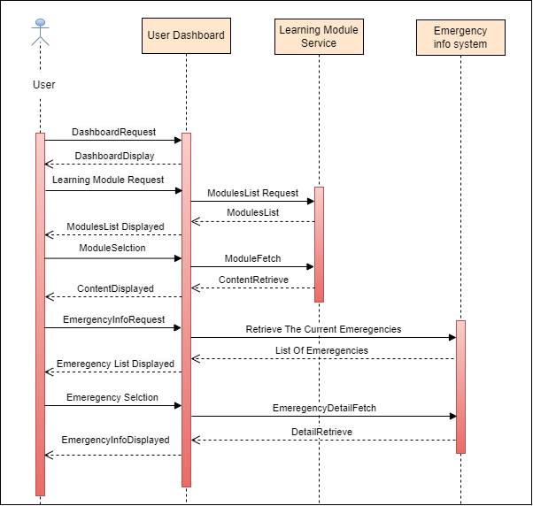

This sequence diagram illustrates the dynamic communication between the platform’s users and its various services. It begins with the user accessing their personalized dashboard, a gateway to the platform’s features. The Learning Module Service plays a pivotal role in delivering educational content, while the Progress Tracker diligently records the user’s achievements. Simultaneously, the Emergency Information Service ensures that users have immediate access to critical emergency updates, fostering an environment of awareness and preparedness. This flow is not just a series of interactions but a narrative of empowerment, education, and safety.

### 3.5.6 Activity Diagram

In the realm of software development, particularly within the context of emergency preparedness platforms, the activity diagram serves as a pivotal tool for visualizing the dynamic flow of user interactions. This diagram is instrumental in delineating the sequence of activities that users engage in, from initial entry points such as registration and sign-in, to critical functions like receiving alerts and accessing learning modules. It encapsulates the essence of user experience, providing a roadmap for developers to understand and enhance the system’s usability.

### 3.5.7 User Interaction Activity Diagram

The following activity diagram, is meticulously crafted to illustrate the comprehensive journey of a user within the system. It commences with the user’s initiation into the platform and unfolds through a series of decision points, alternative paths, and interactive modules, culminating in the contribution and validation of content. This diagram is not merely a representation of actions but a narrative of the user’s engagement with the platform, ensuring they are well-equipped and informed in the face of emergencies.

Figure 3-7. User Interaction Activity diagram

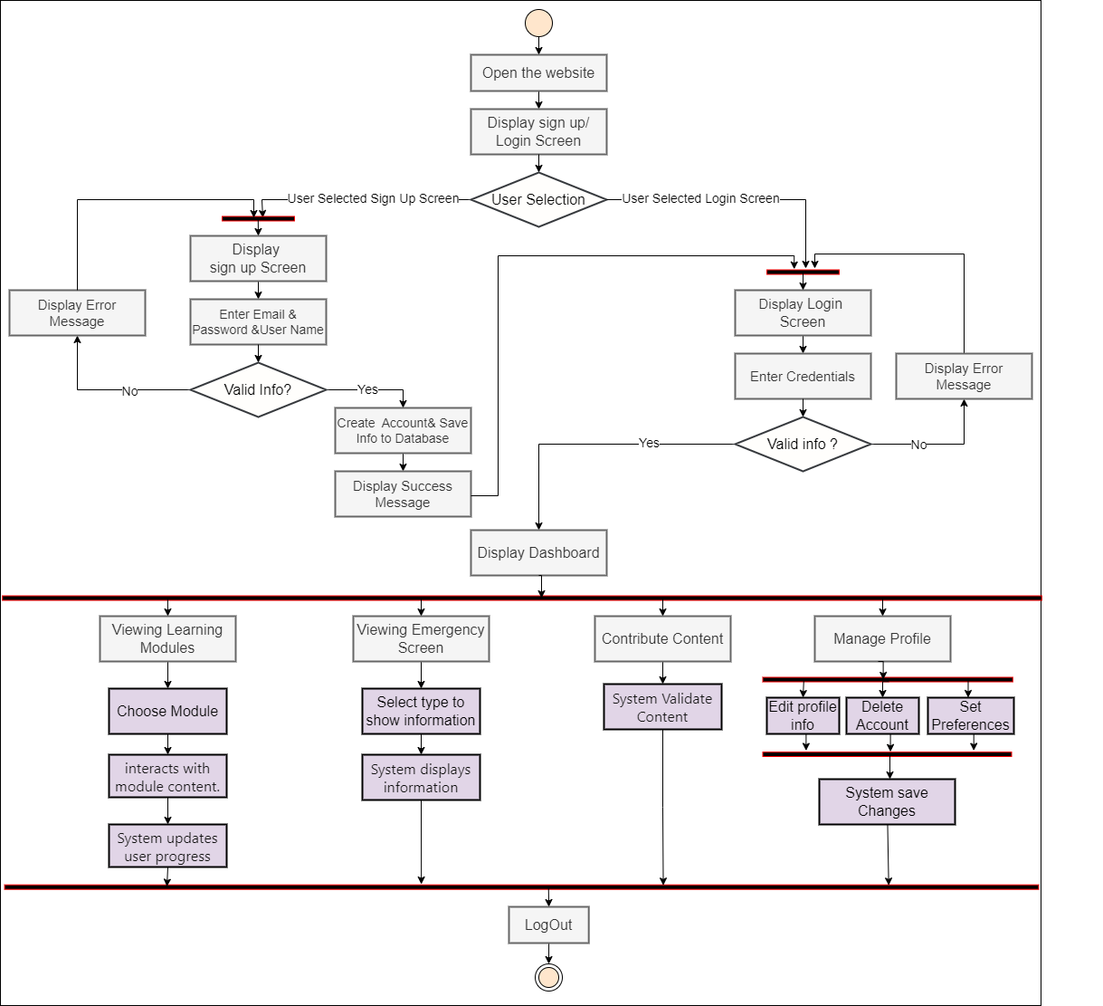

### 3.5.8 Admin Activity Diagram

The Admin Activity Diagram is a succinct and strategic visualization of the core administrative functions within our emergency preparedness platform. It outlines the critical pathways and decision points that administrators encounter, offering a streamlined perspective on the backend operations. This diagram is an essential guide for administrators to efficiently manage the platform, ensuring its robust performance and reliability. It encapsulates the fundamental tasks from login procedures to data management, reflecting the structured approach vital for overseeing a sophisticated system.

Figure 3-8 .Admin Interaction Activity diagram

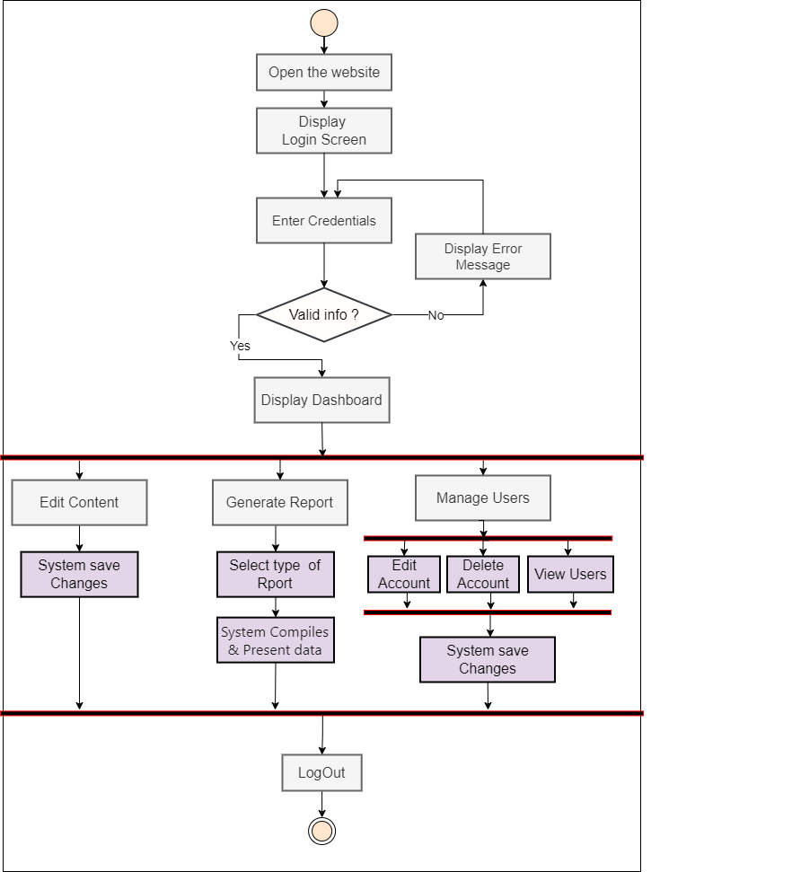

### 3.5.9 Entity Relationship Diagram

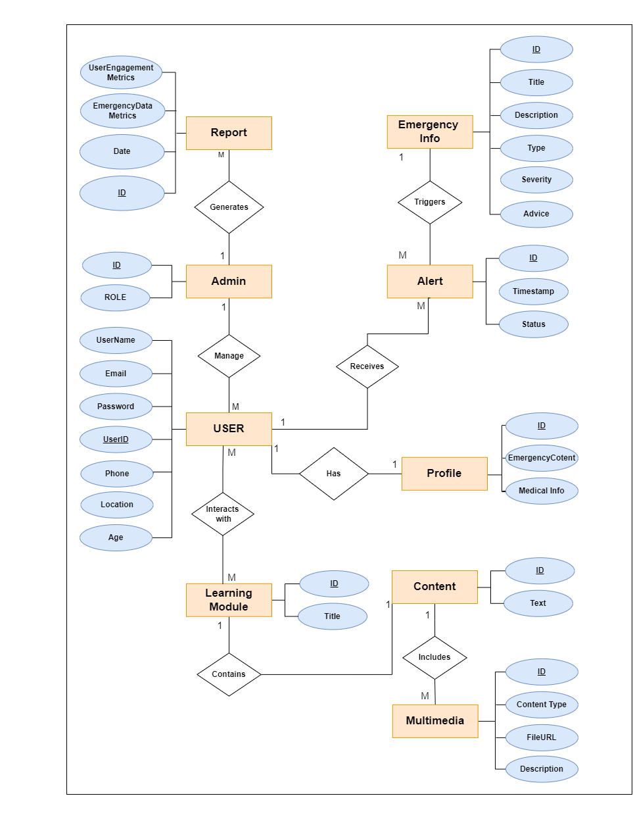The Entity Relationship Diagram (ERD) is a strategic tool that models the data relationships and architecture of our emergency preparedness platform. It serves as a blueprint, detailing how entities such as users, administrators, and system components interconnect and interact. This diagram is crucial for developers and database administrators to visualize the platform’s data structure, ensuring data consistency, integrity, and efficient database design. The ERD helps in identifying the key entities and their relationships, providing a clear understanding of the database’s organization and facilitating the development of robust functionalities within the platform.

Figure 3-9 . Entity Relationship Diagram

### 3.5.10 UML Class Diagram

The UML Class Diagram is a cornerstone of object-oriented analysis and design, providing a visual representation of the system’s structure. This diagram illustrates the classes within the system, their attributes, methods, and the relationships among them, such as associations, inheritances, and dependencies. It serves as a blueprint for developers, offering a clear and organized view of the system’s components and their interactions. By encapsulating the details of the system’s classes, the UML Class Diagram aids in understanding the underlying architecture, promoting efficient communication among stakeholders, and guiding the development process towards a coherent and functional software application.

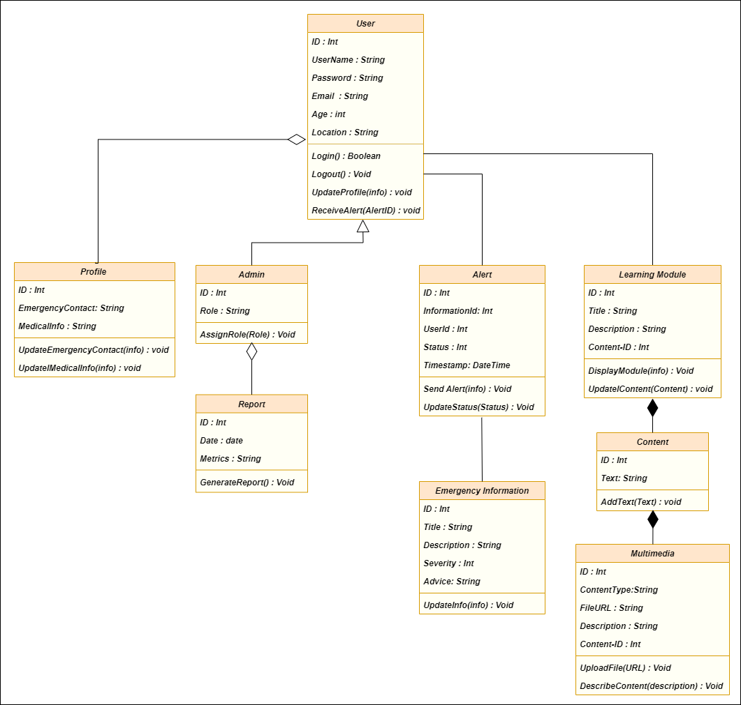

Figure 3-10 . Class Diagram

# CHAPTER FOUR: SYSTEM IMPLEMENTATION

## 4.1 Introduction

This chapter details the implementation of the PrepPal platform, which focuses on providing an interactive and educational emergency preparedness solution tailored for children. The platform utilizes Laravel, a robust PHP framework for backend operations, Supabase for SQL-based data management and real-time capabilities, and Firebase for additional real-time functionalities and authentication services. Additionally, OpenAI is integrated for providing personalized learning recommendations and interactive educational content. The chapter outlines the tools and technologies used, the implementation details of user authentication, child and parent monitoring features, social login, password reset functionalities, and user interfaces.

## Requirements and Tools for Development

##### Table 4-1. Tools and Technologies

|  |  |  |
| --- | --- | --- |
| **Requirement** | **Tool/Technology** | **Purpose** |
| **Web Framework** | Laravel | PHP framework for building robust backend services and APIs. |
| **Backend-as-a-Service (BaaS)** | Supabase | Provides SQL database, real-time data, and user authentication with PostgreSQL compatibility. |
| **Real-Time Capabilities** | Firebase | Offers real-time data synchronization and additional authentication services. |
| **Frontend Framework** | Vue.js | JavaScript framework for building user interfaces. |
| **State Management** | Vuex | Manages the application state for consistency across components. |
| **HTTP Client** | Axios | Handles HTTP requests to the backend APIs. |
| **Social Authentication** | Firebase Authentication | Integrates social login (Google, Facebook, Apple) with easy configuration. |
| **Database** | PostgreSQL (via Supabase) | Stores all platform data, including users, profiles, alerts, and more. |
| **Real-Time Data Handling** | Supabase Realtime | Pushes updates to clients in real-time, enhancing interactivity. |
| **Testing Framework** | PHPUnit | Automates unit and integration testing for backend components. |
| **CSS Framework** | Bootstrap | Provides a responsive design for the platform. |
| **JavaScript Libraries** | JavaScript ES6 | Enhances frontend functionality and user interaction. |
| **Version Control** | Git/GitHub | Manages source code and collaboration among developers. |
| **Development Environment** | Docker | Provides consistent development and deployment environments. |
| **AI Services** | OpenAI APIs | Provides AI-powered personalized recommendations and interactive educational content. |

## User Authentication

User authentication is a crucial aspect of the PrepPal platform, providing secure access for users and enabling the platform's personalized and interactive features. The platform utilizes Firebase Authentication for managing user login, integrating with Laravel's authentication capabilities to provide a seamless user experience.

### 4.3.1 Firebase Authentication

Supabase provides a comprehensive authentication solution that supports various methods, including email/password, social login via OAuth, and magic links for passwordless authentication.

1. **Email/Password Authentication:** The platform supports standard email/password registration, where user credentials are securely stored in Firebase. Firebase Authentication handles the hashing and storage of passwords securely.
2. **Third-Party OAuth Authentication**: The platform integrates Firebase Authentication for social logins via Google, Facebook, and Apple, allowing users to authenticate with their social media accounts, simplifying the registration process.
3. **Magic Links and Passwordless Authentication**: Firebase supports passwordless login, enabling users to log in by clicking a link sent to their email.

### 4.3.2 Registration and Login Flow

The registration and login processes in the PrepPal platform are designed to ensure a secure, user-friendly experience tailored to both children and adults. The flow combines registration and login seamlessly, providing clear pathways based on user age and role.

1. User Registration Form: Users begin by filling out the registration form, providing necessary details such as username, email, password, and age. If a user enters an age below 13, the form dynamically displays an additional field for the parent’s email, which becomes a mandatory input to proceed.
2. Age Verification and Parent Monitoring: The system automatically checks the provided age to determine if the user is a child (under 13). For child users, the parent’s email is required. Upon submission, an automated email notification is sent to the parent’s email address using EmailJS, informing them about their child's registration and requesting consent for monitoring and account approval. This email includes a unique link or instructions for the parent to provide their consent and monitor their child's account activity, ensuring compliance with child safety protocols.
3. User Creation in Firebase: The The registration details, including the child’s information and the parent’s email, are sent to Firebase Authentication, which manages user creation and securely stores user data. Firebase handles the overall authentication process, while EmailJS is utilized to send email verifications to both the child and parent as necessary. This approach leverages Firebase for robust user management and authentication and EmailJS for flexible and customizable email communication.
4. Redirect to Dashboard or Parental Approval: After successfully registering, users are typically redirected to their respective dashboards. However, for users under 13, the account remains in a pending state until parental consent is received and verified. The parent’s approval is crucial for activating the child’s account, ensuring compliance with child safety protocols.
5. User Login: Once registration is complete and any necessary approvals are in place, users can log in using their credentials (email and password) or by selecting a social login option (e.g., Google, Facebook, Apple). Firebase then verifies the credentials against the stored database records.
6. Session Management and Dashboard Access: Upon successful authentication, Firebase issues a JWT (JSON Web Token) for secure session management. This token allows users to maintain a secure session during their interaction with the platform. Depending on their role (child, parent, or admin), users are then directed to their appropriate dashboard, where they can access features and functionalities tailored to their needs.

## Database Implementation

The PrepPal platform uses PostgreSQL, managed through Supabase, to manage a variety of data essential for its operations. The database schema is designed to support robust user management, content delivery, and real-time data handling. Key tables in this schema include:

1. **Users Table**: Stores user credentials, roles, and statuses, integrating seamlessly with Supabase Auth to handle user authentication and authorization.
2. **Profiles Table**: Contains additional user information such as emergency contacts and medical details, ensuring each profile is properly linked to its respective user to maintain data integrity.
3. **Admins Table**: Manages data specific to administrative users, providing a clear distinction between different user roles within the platform.
4. **Emergency Information Table**: Stores detailed information about various emergency scenarios, including descriptions, severity levels, and recommended actions, which are critical for emergency preparedness training.
5. **Alerts Table**: Logs emergency-related alerts and associates them with individual users, ensuring timely notifications and proper tracking.
6. **Reports Table**: Contains data related to administrative reports, covering platform activities and various performance metrics essential for ongoing platform management and improvement.
7. **Learning Modules Table**: Holds information about the educational content offered on the platform, including details about associated materials and the structure of different learning modules.
8. **Multimedia Table**: Stores multimedia resources such as videos and images linked to the learning modules, enhancing the educational experience for users.
9. **Sessions Table**: Manages user session data to ensure secure handling of user access and comprehensive tracking of user activities, enhancing both security and usability.
10. **AI Recommendations Table**: Stores data for personalized learning recommendations, leveraging AI to tailor educational content to each user's learning style and progress.
11. **AI Analysis Logs Table:** Contains logs of user behavior analysis, which are used to refine the AI models that drive personalized content and emergency preparedness resources.

-- Create Users Table

CREATE TABLE users (

  id UUID PRIMARY KEY DEFAULT gen_random_uuid(),

  username VARCHAR(50) NOT NULL,

  email VARCHAR(100) UNIQUE NOT NULL,

  password VARCHAR(255) NOT NULL,

  age INT,

  location VARCHAR(100),

  role VARCHAR(20) CHECK (role IN ('admin', 'parent', 'child')) NOT NULL,

  created_at TIMESTAMP DEFAULT NOW(),

  updated_at TIMESTAMP DEFAULT NOW()

);

-- Create Profiles Table

CREATE TABLE profiles (

  id UUID PRIMARY KEY DEFAULT gen_random_uuid(),

  user_id UUID REFERENCES users(id) ON DELETE CASCADE,

  emergency_contact VARCHAR(100),

  medical_info TEXT,

  created_at TIMESTAMP DEFAULT NOW(),

  updated_at TIMESTAMP DEFAULT NOW()

);

-- Create Admins Table

CREATE TABLE admins (

  id UUID PRIMARY KEY DEFAULT gen_random_uuid(),

  user_id UUID REFERENCES users(id) ON DELETE CASCADE,

  role VARCHAR(20) NOT NULL,

  created_at TIMESTAMP DEFAULT NOW(),

  updated_at TIMESTAMP DEFAULT NOW()

);

-- Create Emergency Information Table

CREATE TABLE emergency_information (

  id UUID PRIMARY KEY DEFAULT gen_random_uuid(),

  title VARCHAR(100) NOT NULL,

  description TEXT,

  severity INT,

  advice TEXT,

  created_at TIMESTAMP DEFAULT NOW(),

  updated_at TIMESTAMP DEFAULT NOW()

);

-- Create Alerts Table

CREATE TABLE alerts (

  id UUID PRIMARY KEY DEFAULT gen_random_uuid(),

  information_id UUID REFERENCES emergency_information(id) ON DELETE CASCADE,

  user_id UUID REFERENCES users(id) ON DELETE CASCADE,

  status VARCHAR(20),

  timestamp TIMESTAMP DEFAULT NOW(),

  created_at TIMESTAMP DEFAULT NOW(),

  updated_at TIMESTAMP DEFAULT NOW()

);

-- Create Reports Table

CREATE TABLE reports (

  id UUID PRIMARY KEY DEFAULT gen_random_uuid(),

  date DATE NOT NULL,

  metrics TEXT,

  admin_id UUID REFERENCES admins(id) ON DELETE CASCADE,

  created_at TIMESTAMP DEFAULT NOW(),

  updated_at TIMESTAMP DEFAULT NOW()

);

-- Create Learning Modules Table

CREATE TABLE learning_modules (

  id UUID PRIMARY KEY DEFAULT gen_random_uuid(),

  title VARCHAR(100) NOT NULL,

  description TEXT,

  content_id UUID REFERENCES content(id) ON DELETE CASCADE,

  created_at TIMESTAMP DEFAULT NOW(),

  updated_at TIMESTAMP DEFAULT NOW()

);

-- Create Content Table

CREATE TABLE content (

  id UUID PRIMARY KEY DEFAULT gen_random_uuid(),

  text TEXT NOT NULL,

  title VARCHAR(100),

  created_at TIMESTAMP DEFAULT NOW(),

  updated_at TIMESTAMP DEFAULT NOW()

);

-- Create Multimedia Table

CREATE TABLE multimedia (

  id UUID PRIMARY KEY DEFAULT gen_random_uuid(),

  content_type VARCHAR(50),

  file_url TEXT,

  description TEXT,

  content_id UUID REFERENCES content(id) ON DELETE CASCADE,

  created_at TIMESTAMP DEFAULT NOW(),

  updated_at TIMESTAMP DEFAULT NOW()

);

-- Create Sessions Table

CREATE TABLE sessions (

  id VARCHAR(255) PRIMARY KEY,

  user_id UUID REFERENCES users(id) ON DELETE CASCADE, -- Optional: If you want to link sessions to users

  ip_address VARCHAR(45) NULL,

  user_agent TEXT NULL,

  payload TEXT NOT NULL,

  last_activity INT NOT NULL

);

-- Create AI Recommendations Table

CREATE TABLE ai_recommendations (

  id UUID PRIMARY KEY DEFAULT gen_random_uuid(),

  user_id UUID REFERENCES users(id) ON DELETE CASCADE,

  recommendation_type VARCHAR(50) NOT NULL, -- e.g., 'content', 'activity', 'module'

  recommendation_text TEXT NOT NULL, -- Description or details of the recommendation

  created_at TIMESTAMP DEFAULT NOW(),

  updated_at TIMESTAMP DEFAULT NOW()

);

-- Create AI Analysis Logs Table

CREATE TABLE ai_analysis_logs (

  id UUID PRIMARY KEY DEFAULT gen_random_uuid(),

  user_id UUID REFERENCES users(id) ON DELETE CASCADE,

  analysis_type VARCHAR(50) NOT NULL, -- e.g., 'behavior', 'engagement', 'performance'

  analysis_result TEXT NOT NULL, -- Result or outcome of the AI analysis

  logged_at TIMESTAMP DEFAULT NOW(), -- When the analysis was logged

  created_at TIMESTAMP DEFAULT NOW(),

  updated_at TIMESTAMP DEFAULT NOW()

);

## Frontend Implementation

The frontend of PrepPal is built using Vue.js, providing a responsive and interactive user experience. The frontend is designed to cater to both children and adults, with features that adapt based on the user’s role.

### 4.5.1 Vue.js and Vuex for State Management

1. **Component-Based Architecture**: The platform utilizes Vue.js for building reusable components, ensuring a modular and maintainable codebase. Components are developed for various functionalities such as registration, login, user dashboard, and parental monitoring.
2. **State Management with Vuex**: Vuex is used to manage application state, ensuring data consistency across components and facilitating complex state interactions like user authentication state, real-time updates from Supabase, and UI feedback.

### 4.5.2 User Interface and Design

1. **Responsive Design with Bootstrap**: Bootstrap is integrated for responsive design, ensuring that the platform is accessible on various devices, including desktops, tablets, and smartphones.
2. **Interactive and Accessible Elements**: The UI elements are designed to be engaging for children, with bright colors, animations, and interactive components that encourage learning about emergency preparedness. Accessibility features such as screen readers, keyboard navigation, and high-contrast modes are also implemented.

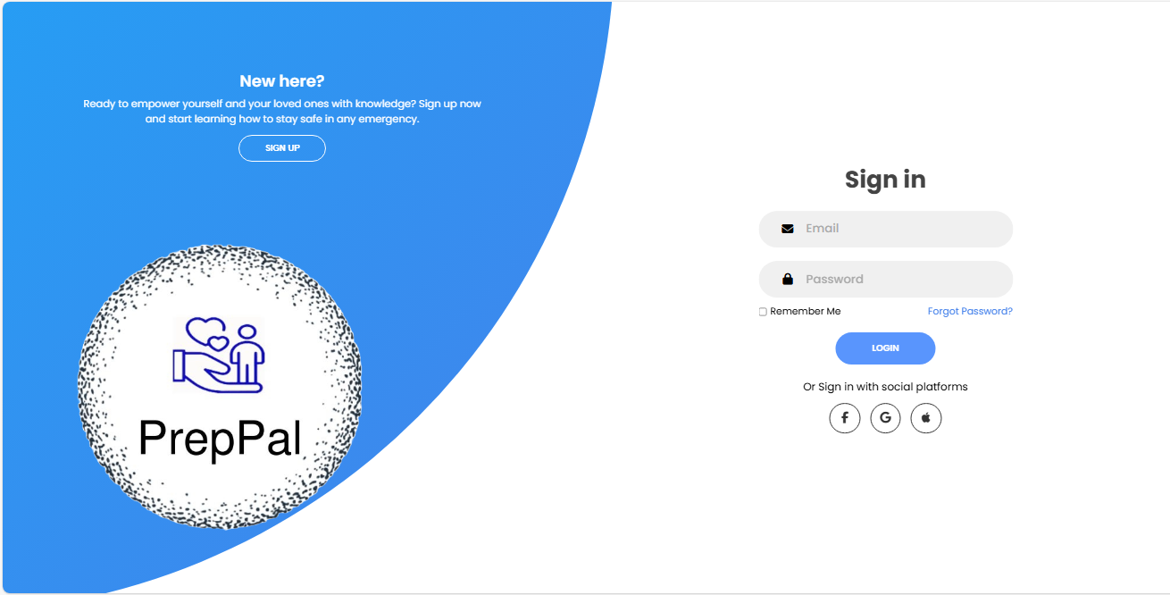

Figure 4-1 . Login Interface.

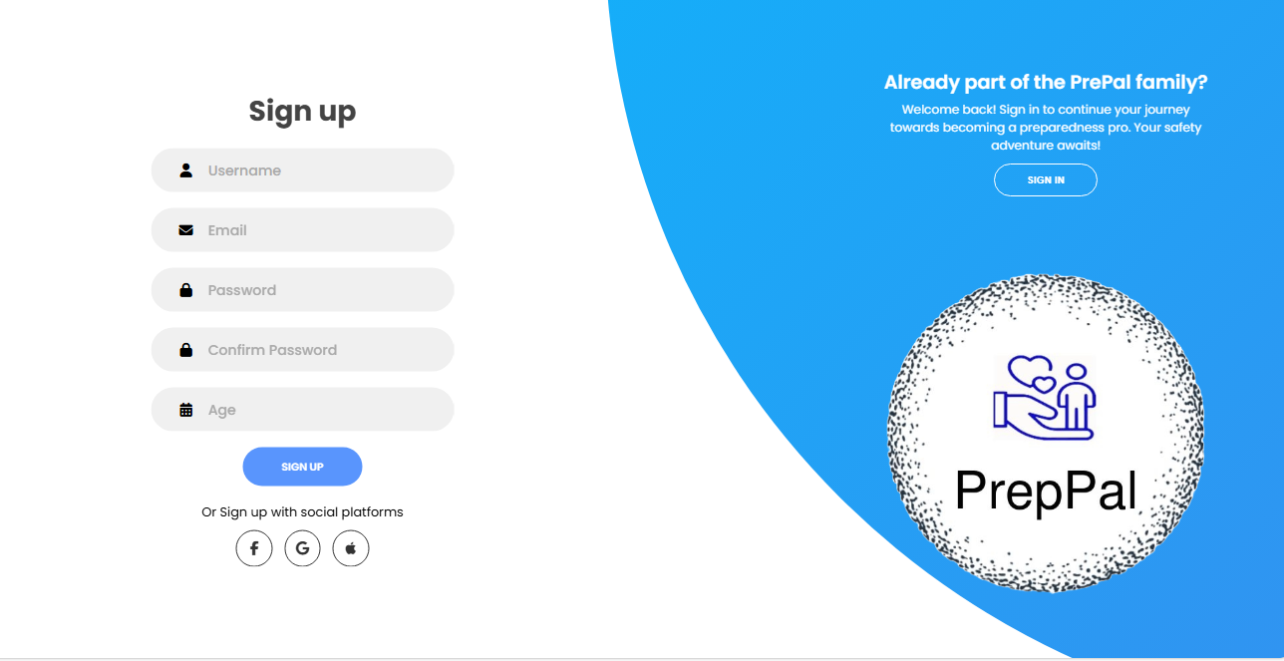

Figure 4-2 . Signup Interface.

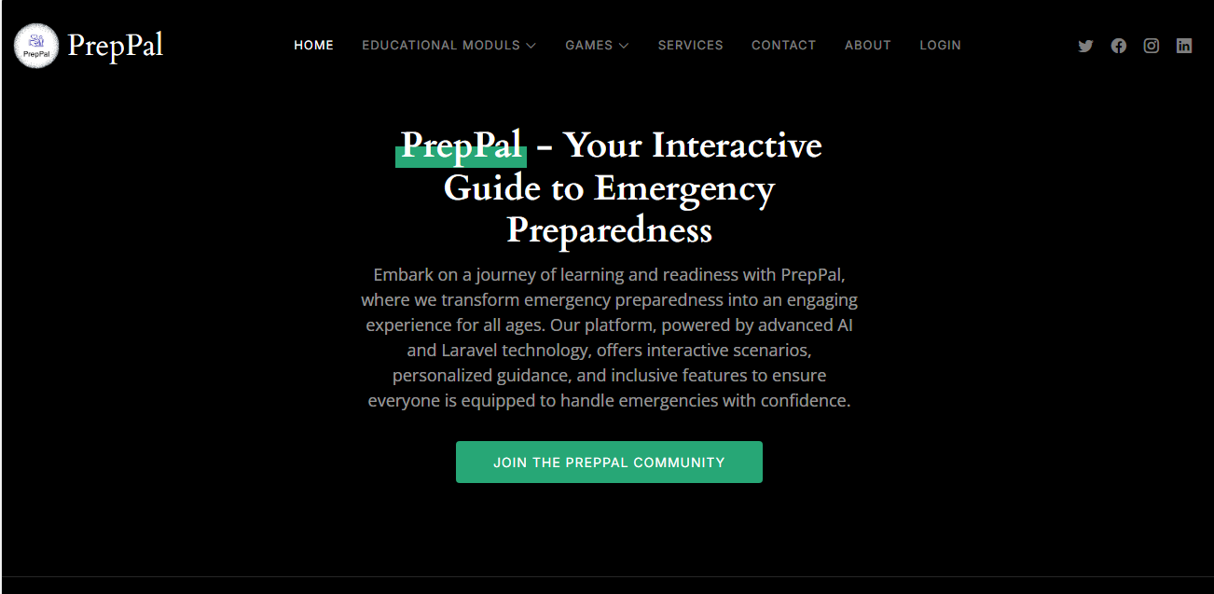

Figure 4-3 . Home Interface.

## Social Login and Password Reset

To enhance user convenience, the platform includes social login options and a robust password reset mechanism.

### 4.6.1 Social Login Implementation

Social logins are facilitated through Laravel Socialite, providing seamless integration with third-party OAuth providers like Google, Facebook, and Apple.

1. **Simplified Registration**: Users can quickly register using their existing social media accounts, reducing the friction of traditional registration processes.
2. **Enhanced Security**: By leveraging third-party OAuth providers, the platform benefits from their advanced security features, such as multi-factor authentication (MFA).

### 4.6.2 Password Reset Functionality

The password reset process is crucial for user retention and security.

1. **Password Recovery**: Users can initiate a password reset via a "Forgot Password?" link, which triggers an email with a secure reset link.
2. **Firebase Token Management**: Firebase handles secure token generation and verification for the password reset process, ensuring that the operation is both secure and user-friendly.

# References

1. United Nations Office for Disaster Risk Reduction. "*Global Assessment Report on Disaster Risk Reduction 2019"*. 2019. [Online]. Available at: <https://www.undrr.org/publication/global-assessment-report-disaster-risk-reduction-2019>.
2. Save the Children. (2019). *Protecting Children in Emergencies* [Online]. Available:

<https://www.savethechildren.org/us/what-we-do/protection/protecting-children-in-emergencies>.

1. Deployment - Laravel 10.x - The PHP Framework For Web Artisans. Retrieved from: <https://laravel.com/docs/10.x/deployment>.
2. AI and data science for smart emergency, crisis and disaster resilience, International Journal of Data Science and Analytics, Springer, 2023. Available: <https://link.springer.com/article/10.1007/s41060-023-00393-w>.
3. Leveraging AI in emergency management and crisis response, Deloitte Insights. Available: <https://www2.deloitte.com/us/en/insights/industry/public-sector/automation-and-generative-ai-in-government/leveraging-ai-in-emergency-management-and-crisis-response.html>.
4. Research on the Construction of Intelligent Community Emergency Service Platform, Hindawi. Available: <https://www.hindawi.com/journals/sp/2021/5089236/>.
5. How AI can help protect us from disasters, ITU Hub. Available: <https://www.itu.int/hub/2022/03/ai-disaster-management-early-warning/>.
6. Early Childhood Development in Emergencies - UNICEF. [Online]. Available: <https://www.unicef.org/media/73736/file/Programme-Guide-ECDiE-2014.pdf.pdf>.
7. Early childhood development in emergencies | UNICEF. [Online]. Available:

<https://www.unicef.org/early-childhood-development-emergencies>.

1. History of Emergency Preparedness | NRC.gov. [Online]. Available: <https://www.nrc.gov/about-nrc/emerg-preparedness/history.html>.
2. Deloitte. "*Leveraging AI in emergency management and crisis response*." Deloitte Insights. [Online]. Available: <https://www2.deloitte.com/us/en/insights/industry/public-sector/automation-and-generative-ai-in-government/leveraging-ai-in-emergency-management-and-crisis-response.html>...
3. Hindawi. "*Research on the Construction of Intelligent Community Emergency Service Platform Based on Convolutional Neural Network*." International Journal of Data Science and Analytics. [Online]. Available:  <https://www.hindawi.com/journals/sp/2021/5089236/> .
4. C. Vermiglio, G. Noto, M. P. Rodríguez Bolívar, and V. Zarone, "*Disaster management and emerging technologies: a performance-based perspective,*" Meditari Accountancy Research, vol. 30, no. 4, pp. 1093-1117, Aug. 2022. [Online]. Available: <https://www.emerald.com/insight/content/doi/10.1108/MEDAR-02-2021-1206> .
5. J. Doe and A. Smith, "*Research on the Construction of Intelligent Community Emergency Service Platform Based on Convolutional Neural Network,"* Journal of Science, vol. 20, no. 3, pp. 123-136, Mar. 2021. [Online]. Available: <https://www.hindawi.com/journals/sp/2021/5089236/> .
6. A. Johnson, "*Applications of artificial intelligence for disaster management,"* Natural Hazards, vol. 50, no. 4, pp. 1001-1020, Apr. 2020. [Online]. Available: <https://link.springer.com/article/10.1007/s11069-020-04124-3>.
7. Pacific Disaster Center, "*DisasterAWARE*," [Online]. Available: <https://www.disasteraware.com/>.
8. Qatar Computing Research Institute, "*AI for Disaster Response (AIDR),"* [Online]. Available: <https://aidr.qcri.org/>.
9. Saudi Arabia Ministry of Interior, "*Saudi Arabia Emergency Management System* (SAEMS)," [Online]. Available: <https://safetyculture.com/topics/emergency-preparedness-and-response/>.
10. Centers for Disease Control and Prevention, "*Ready Wrigley,"* [Online]. Available: <https://www.cdc.gov/cpr/readywrigley/index.htm>.
11. American College of Emergency Physicians, "*Disaster Hero*," [Online]. Available: <https://www.disasterhero.com/>.
12. American Red Cross, "*Prepare with Pedro*," [Online]. Available: <https://www.redcross.org/get-help/how-to-prepare-for-emergencies/mobile-apps/prepare-with-pedro.html>.
13. Ready.gov. "*Plan Ahead for Disasters*." Available at: <https://www.ready.gov/>.
14. University of Southern California, "*Disaster Preparedness and Response Assistant (DPRA),"* [Online]. Available: <https://safetyculture.com/topics/emergency-preparedness-and-response/>.
15. LambdaTest. (n.d.). 5 Most Popular Types of SDLC Models. Retrieved from <https://www.lambdatest.com/blog/sdlc-models/>.
16. Hygger.io. (n.d.). How to Choose the Best SDLC Methodology for Your Project?. Retrieved from <https://hygger.io/blog/choosing-sdlc-methodology-for-projects/>.
17. H. Clark, "*The Software Development Life Cycle (SDLC): 7 Phases and 5 Models,*" The Product Manager, [Online]. Available: <https://theproductmanager.com/topics/software-development-life-cycle/> .
18. GeeksforGeeks. "*Agile Software Development - Software Engineering*." [Online]. Available: <https://www.geeksforgeeks.org/software-engineering-agile-software-development/>.

1. monday.com. "*Agile development: What is Agile SDLC and how to use it?"* [Online]. Available: <https://monday.com/blog/rnd/agile-sdlc/>.